13 Dec 2022 14:30
SATI  tarryn@satgi.co.za  Tel: 021 863-0366 | CFPA  inmaak@mweb.co.za  Tel: 021 872-1501 | HORTGRO  anita@hortgro.co.za  Tel: 021 870 2958 | RAISIN SA  ferdieb@raisinsa.co.za  Tel: 054 495 0283 | WINETECH  andraga@winetech.co.za  Tel: 021 276 0499
 |  |  |  | X

FINAL REPORT 2022

Winetech Number: FShip Water 1
1. PROGRAMME & PROJECT LEADER INFORMATION
 | Research Organisation leader | Project leader
Title, initials, surname | Prof Melane Vivier | Dr. CA Poblete-Echeverría
Present position | Director of SAGWRI | Senior Lecturer
Address | Department for Viticulture and Oenology, Stellenbosch University | Department for Viticulture and Oenology, Stellenbosch University
Tel. / Cell no. | 021-808 3773 | 021-808 2747
E-mail | mav@sun.ac.za | cpe@sun.ac.za
2. PROJECT INFORMATION
Project title | Integrated vineyard monitoring system to improve water management
Short title | IVMS

Fruit kind(s) | Grapevines
Start date (mm/yyyy) | 2019-08 | End date (mm/yyyy) | 2022-08

Key words | New technologies, Water management, Spatial and temporal variability

 | CFPA | RAISIN SA | HORTGRO | SATI | WINETECH | ARC | OTHER
TOTALS All years | R 0 | R 0 | R 0 | R 0 | R 1120327 | R 0 | R 0

Total cost of entire project | R 1120327

3. EXECUTIVE SUMMARY

Objectives and Rationale
The objective of this project was to implement a research site where multiple technologies were integrated and tested for monitoring the response of vines to water deficit, considering spatial and temporal variability.

Methods
To collect relevant data from the selected experimental vineyard block, five monitoring units were established: Unit1 -Micrometeorological, Unit2 - Meso and microclimate, Unit3 in-vine monitoring, Unit4 - In-soil monitoring and Unit5 - Remote sensing. These units were designed and planned to consider the most important factors of variability.

Key Results
All monitoring units proposed were successfully established and data were collected during two consecutive growing seasons. With the datasets collected and the subsequent analysis, it was possible to implement a water stress classification of the block. The classes presented a clear effect of the water stress with significant differences.

Key Conclusion of Discussion
The statistical analysis of the classification proposed, indicated significant differences in fruit and wine quality parameters among the water stress classes. The vines under class 1 (water-stressed vines) presented 50 % lower values of yield. Overall, 30% variation in chemical compounds were seen with water-stressed plants being generally higher.

Take Home message for Industry
We present solid evidence about the effects of water stress on fruit and wine quality parameters. Also, we demonstrate the potential use of innovative technological tools for monitoring water stress considering spatial and temporal variability. Improvements in the methodologies proposed in this study are the basis for the new FShip3 project.

4. PROBLEM IDENTIFICATION AND MOTIVATION
Problem Identification

Due to the complexity of future climatic scenarios, it is critical for developing the next generation of integrated technologies and vineyard systems to improve water management and maintain the international competitiveness of the SA wine industry.
Winetech is undertaking a Water Research Program titled: “Grapevine production with limited water resources” and this sub-project forms part of this new program. This program aims to establish a theoretical framework; a scientific network; and research to provide new information and ultimately practical advice with regards to the minimum water requirement, for economically viable wine production in a changing environment. The higher-level drivers/goals of this program would be to ensure sustainable, profitable, and quality products from the current, and even future cultivar profile in the context of the potential impacts of climate change.

The premise for the research program is that although existing knowledge is available, that could immediately be consolidated and transferred to the industry as the current best practices with regards to water-regimes for yield and quality, information is required on (current) new technologies and tools to monitor water availability towards optimal, but water-wise production schemes.

Motivation

The IVMS will provide the possibility to implement adaptation strategies using more accurate and adequate monitoring techniques that can also be carried out in a rapid and cost-effective manner for the viticultural industry at different scales (Intra block variability and vineyard variability). The units of the IVMS will be analysed as a whole and independently to have an overview of the interactions and potential practical applications of each unit.
This study will provide critical information to a range of new and ongoing R&D projects as well practical information, such as the water consumption of a standard vineyard (VSP - vertical shoot positioned with standard commercial practices) in the Stellenbosch area.

The main objective of this sub-project is to implement a research site where multiple technologies will be integrated and tested for the monitoring of the response of vines to water deficit, considering spatial and temporal variability (Integrated Vineyard Monitoring System - IVMS). IVMS is an essential part of the broader research program that will focus on water management to ensure sustainable, profitable, and quality products from the current, and even future cultivar profile in the context of the potential impacts of climate change.

5. ACCUMULATED PROGRESS TABLE
Objectives | Milestones (Significant event or stage in a project) | Date Achieved
1. Establish the integrated monitoring system (IVMS) in an existing vineyard (Season 2019-2020) | 1.1. Identifying the research site (existing vineyard) - On track  1.2. Defining a simplified experimental design, considering extreme water stress conditions (no-stress versus severe water stress) and natural spatial variability - On track  1.3. Configuration of monitoring units of the Integrated Vineyard Monitoring System (IVMS) - On track  1.4. Data collection during the first season - On track  1.5. Data analysis and interpretation - On track | 2020-11-30
2. IVMS testing (Season 2020-2021) | 2.1. Configuration and optimization of monitoring units of the IVMS - On track  2.2. Data collection during the second season - On track  2.3. Data analysis and interpretation (second season) - On track | 2021-08-10
3. Integrated data analysis and final report. | 3.1. Integrated data analysis (Season 1 and 2). - On track  3.2. Final report - On track | 2022-08-10

6. WORKPLAN (MATERIALS AND METHODS)

Objective 1:
Establish the integrated monitoring system (IVMS) in an existing vineyard (Seasons 2019-20 and 2020-21).
1.1. Identifying the research site (existing vineyard).
The block selection was made by considering strategic location, security, and access to avoid any issues in the experimental area block. Thelema Mountain Vineyards was selected. The experimental site is located at the Stellenbosch Wine of Origin district, Simonsberg-Stellenbosch ward – South Africa (SAWIS, 2014), 33°54'11.8"S - 18°55'12.4"E, 430 m above sea-level. The selected block “W1B” (Figure 2) has a surface of 2.4 ha and was planted in the year 2003 with cv. Cabernet Sauvignon vines (rootstock 101/14). The vines were trained to a Vertical Shoot Positioning (VSP) trellis system with bi-lateral cordon and spur pruned. The historical average yield in the block is 8.24 Ton/ha with an average of 4.0 kg/vine.
The selected block is a premium block that has been well established since it was planted in 2003. It is a clean block with no obvious diseases or viruses to report on. Figure 1a) shows an image of the selected block. Figure 1b) shows the water flow direction across the block. In Figure 1b, colours show the difference in the water flow direction. The water flow at the top of the block is in the SE direction whereas at the bottom of the block the water flows in an SW direction.
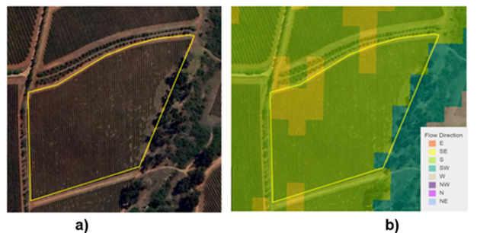
Figure 1 a) The selected W1B Block and b) Flow direction (Image obtained through Cape farm mapper, Elsenburg).
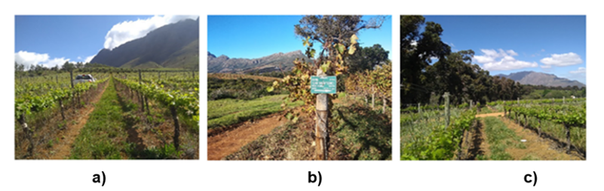
Figure 2 Thelema vineyards from 3 different angles showing the a) row width the b) block information c) the bottom tree section.
1.2. Defining a simplified experimental design, considering extreme water stress conditions and natural spatial variability.
The design of the existing experimental vineyard incorporated two different trials to study water management conditions:
Trial 1. Comparison between dryland and double-line irrigation (including a control).
This experiment was implemented using a simplified experimental design, considering extreme water stress conditions (no-stress = double-line irrigation v/s stressed = dryland/non-irrigated) with continuous monitoring of soil water content and plant water status.
The selected target vines were exposed to one of 3 conditions (Figure 3). In condition 1 (a) the vines were exposed to the normal irrigation plan set out by the farm (commercially irrigated). In condition 2 (b) the irrigation lines were doubled (these plants received double the amount of water). In condition 3 (c) an additional blind line (no drippers) was added, and the dripper-line was bypassed to ensure that condition 3 vines did not receive any water. Table 1 summarizes the water delivery available to each condition during a scheduled irrigation.

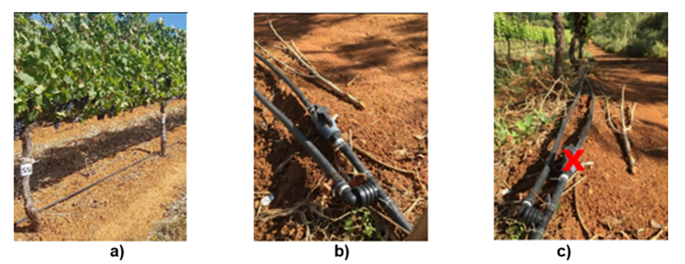
Figure 3 Description of the 3 conditions used during Trail 1 and 2. a) Condition 1; the controlled commercial irrigation b) Condition 2; the double-line (commercial irrigation doubled with 2 lines) and c) Condition 3 the dry land (non-irrigated).
Table 1 Dripper delivery available to each irrigation condition described.
Control  (Commercial irrigation) | Double irrigation  (Double the commercial irrigation) | Dryland
2.3 L/h 600mm spacing | 4.6L/h 600mm spacing | No irrigation

Testing season (2020-2021) – optimization.
The commercial irrigation management was very restrictive during the first season. In the testing season (2020-2021), the double-line irrigation strategy was replaced by a threshold approach with manual irrigation. In this new approach, a threshold of -0.9 MPa (Midday stem water potential) was defined. The vines were maintained over the threshold during the whole growing season. Dryland and commercial irrigation strategies were maintained without modifications. The experimental layout for Trail 1 is described in Figure 4.

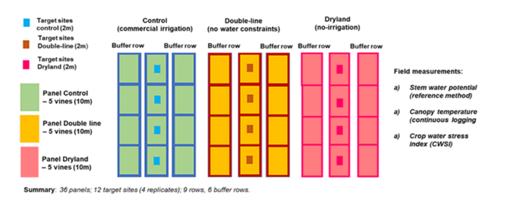
Figure 4 Summary of the experimental layout for Trail 1.

Trial 2. Water consumption and spatial variability (natural variability assessment).
Selection of the target vines for Trail 2:
A combination of plant, soil and water factors were measured and analysed to implement the selection of the target vines, in order to cover, all the spatial variability conditions (different levels of vigour) presented in the experimental block. Soil surface electrical conductivity (ECa), Trunk circumference (TC), and Normalized difference vegetation index (NDVI) (from previous seasons) were used to locate the target sites. Data from ECa, and TC were analysed generating classes of variability using the standard unsupervised k-means (Huang et al., 2005) function in R. The clusters were ordered in ascending way and then in the matching areas the targets vines were located considering a separation of 5 vineyard rows to cover the whole vineyard block. In result, a total of 43 target vines were selected (Figure 5). All the target plants were Geo-references using a Garmin eTrex 10 GPS. The GPS locations of each vine in the block were manually Geo-corrected using the number of vines per row, and the distance between vines. Target vines were subjected to the same canopy management, vine treatments and irrigation schedules during the growing season.
Testing season (2020-2021) - optimization
During the testing season, the selection of target sites was optimized redefining the target areas according to the results of the first season. Target areas with similar responses to water stress conditions were grouped. The optimized target sites are presented in Figure 5.
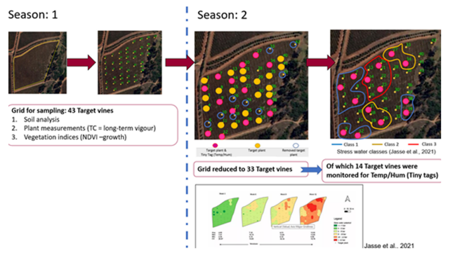
Figure 5. Schematic representation of the optimization method used in the testing season.

1.3. Configuration of monitoring units of the Integrated Vineyard Monitoring System (IVMS) & 2.1. Configuration and optimization of monitoring units of IVMS.
The methodology used to achieve objectives 1.3 and 2.1 is presented combined indicating the changes and optimizations implemented during the testing season (2020-2021).

Unit 1. Micrometeorological monitoring:
A simplified energy balance system (Poblete-Echeverría and Ortega-Farias 2012) with 4 components was installed at the experimental site: i) data-logger, for programming and storage of data; ii) 4-way net radiometer, for measuring the energy balance between incoming and outgoing short-wave and long-wave radiation (Rn); iii) thermocouple, for measuring the surface temperature (vines and soil), and iv) energy source (batteries and solar panel) to provide energy to the system for continuous monitoring.
Unit 2. Meso and microclimate monitoring:
Meso-climate
Meso climate was characterized by data obtained from a nearby weather station (Tokara weather station). The data was downloaded via a commercial website iLeaf accessible to us through the producer. iLeaf provided us access to the following variables: Temperature, Relative humidity (RH), Solar radiation, Wind speed, wind direction as well as data generated from the ETo model. The iLeaf website also gives access to other weather models that can be included (Cold units, heat units, Growing Degree Days, Dew point, Historical spray conditions).
Microclimate
To characterize the microclimate variability in the experimental block, a network of mini weather stations (temperature and relative humidity, Tinytag® loggers Figure 7a, TinyTag Plus 2 - TGP4500, Gemini Data Loggers (UK) Ltd., Chichester, United Kingdom) was installed in the bunch zone.
Testing season (2020-2021) - optimization
In the first season, TinyTag's were installed in 14 target vines, 7 vines located at the top of the block and 7 in vines located at the bottom of the block considering the slope and the water flow direction. In the testing season, the location of the 14 Tinytag's was optimized. The sensors were installed in specific target vines selected from the water stress classes defined in the first season.
Light measurements
Photosynthetic active radiation (PAR) light measurements were taken with an AccuPAR model LP-80 sensor ranging in the 400 – 700nm waveband. This was only done once in the season for all the points Trail 1 and Trail 2. The measurements were taken on both sides of the canopy (East vs West) in the bunch zone as well as ambient light measurements between the rows for each point in season 1. In Season 2 a once of measurement was done mid-morning only on the east side of the canopy.
Unit 3. In-Vine monitoring:
Stem Water Potential (SWP)
The stem water potential was used as the main reference method to define the water status of the vines (Trial 1 and 2). SWP was used to compare alternative methods and perform water stress classifications. Midday stem water potential (SWP) was measured weekly, from November to the end of February, using a pressure chamber (PMS Instrument Company, model 1505D, Albany, USA). SWP was measured around midday (12:00 to 13:00 local time) on every target vine for Trail 1 and 2. Mature and healthy leaves were selected from the middle of the canopy, facing the shaded side of the canopy to avoid overheating. To diminish leaf transpiration each selected leaf was covered with aluminum foil inside a plastic zip bag at least 1 hour before midday measurements (Chone et al., 2001).
Canopy area
RGB (red, green, and blue) and NGB (near green, blue /modified RGB) images using a white panel (WP) as a background was taken for each of the 12 target plants for Trail 1 (condition 1, 2 and 3) as well as each of the target vines in Trail 2 (43 first season and 33 testing season). A MATLAB code was developed to process the images to determine the Leaf area index (LAI).
Testing season (2020-2021) - optimization
The WP used in season one was optimized to a fixed structure to make sure the reference square was stable in-between image analysis (Figure 6).
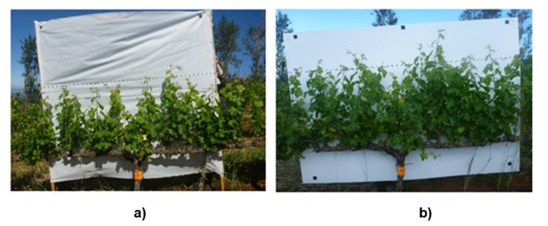
Figure 6. White panel used for canopy area measurements. a) WP with unstable black square reference. b) WP with stable square reference.

The MATLAB code used in the first season was optimized to ensure a more accurate estimation of lateral leaf area (LLA). This new method estimates grapevine from RGB imagery by making use of colour thresholds and automatic k-means image segmentation (Figure 7).
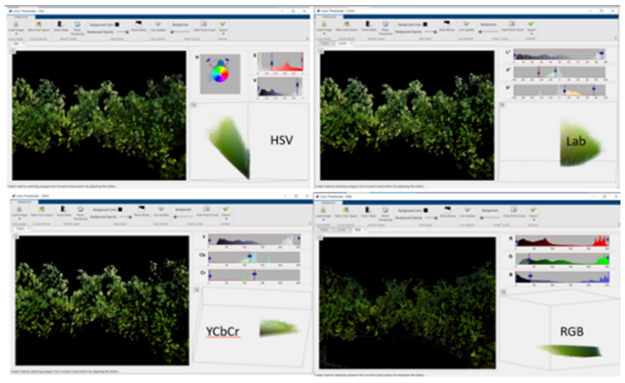
Figure 7. Four colour spaces used for the colour thresholding process: RGB (red, green, blue), HSV (hue, saturation, value), YCbCr (brightness, Cb, Cr) and CIELab (luminance, green to red, blue to yellow).
Canopy temperature and CWSI
Thermal images were acquired weekly from 10:00 to 12:00 using different thermal cameras (Guide IR9, FLIR C3, and low-cost Panasonic infrared array) and protocols. Reference leaf temperatures (Tdry and Twet) were measured at the start and end of each row. These two extreme values were used to calculate the crop water stress index (CWSI) (Jones et al., 2002; Poblete-Echeverría et al., 2016; Sepúlveda-Reyes et al., 2016).
Testing season (2020-2021) - optimization
Changes in the methodology used to capture the thermal images were implemented, considering distance to the target vines, time of acquisition (light conditions), the angle between the camera and the objective, and background interference.
Trunk circumference (TC)
TC values of target vines were determined manually by measuring the trunk circumference at an average section between 10 cm above the graft union and 10 cm below the head of the vine. TC measurements were done for all vines in Trail 1 and 2. In Season 2 with support from the SAGWRI honour's program we increased the TC measurements from 52 to 576 vines across the 2.42 ha block.
Shoot length-model (SL-model)
During the first season, a shoot length empirical model was created collecting shoots with different lengths during the whole growing season (Johnson et al., 2003; Poblete-Echeverria and Ortega-Farias, 2009). The leaf area per shoot was determined by an image analysis process using a customized MATLAB code.
Testing season (2020-2021) - optimization
The SL-model developed during the first season was validated in the testing season by measuring shoot length and real leaf area index using a destructive method on 16 target vines (Figure 8a and b). In the testing season more shoot length data was collected to further improve the model. The model will be tested with a once of shoot-length dataset collected by the SAGWRI honour's program.
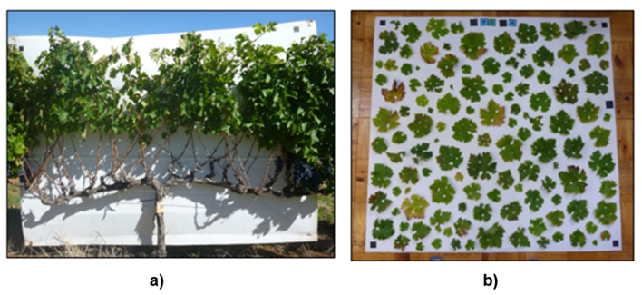
Figure 8. a) Example of a partially stripped vine; b) RGB-image of leaves for leaf area image analysis with MATLAB.

Gas Exchange
Measurements of photosynthetically active radiation (PAR), net CO2 assimilation (AN), stomatal conductance (gs), and leaf transpiration (E) were done by using a portable infrared gas analyser (LI-6400, LI-COR Inc., Lincoln, Nebraska, United States). The molar air flow rate inside the leaf chamber was set to 500 µmol/mol. All leaf conditions were maintained with no external light, CO2 and temperature control was used (Zuniga et al., 2018). Gas exchange measurements were only done on Trial 1 on specific days as an additional day cycle experiment.
Phenological stage (EL-stage)
EL-stage was monitored weekly by making use of the Modified Eichhorn-Lorenz (EL) (Dry and Coombe 2004) code in all target plants for Trail 1 and 2. Ripeness was then followed by combining sugar measurements (°Brix) using a refractometer.
Nutrition analysis (Leaf and petiole analysis)
A collaboration was established with Villa Crop in order to measure plant nutrients in the leaf/petiole with the aim to understand the impact that water stress has on the vine plant physiology. A full nutrient analysis for each of the target vine for Trail 1 and Trail 2 was done three times during the season (Flowering, Veraison, and Harvest) on representative leaf/petiole samples.
Unit 4. In-Soil monitoring:
Neutron probe
Relative soil water content measurements were obtained every week from September to March, at 20cm and 40cm depth (root zone) using a Neutron Probe (CPN International, model 503DR Hydroprobe, CA, USA). Measurements were taken for all target plants in Trail 1 and 2. PVC plastic pipes with 50 mm diameter and endcaps, were inserted at a depth of 50cm.
Testing season (2020-2021) - optimization
During the testing season a calibration protocol is being implemented to convert the neutron probe readings in volumetric soil water content (Myburgh, 2018). An example of the measurements in the field is presented in Figure 9.

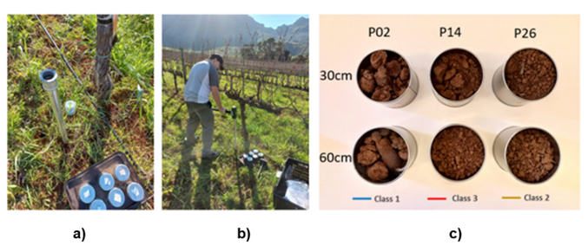
Figure 9. Example of the measurements used to calibrate NP readings. a, b) Procedure being followed to sample soil at 30 and 60 cm. c) visual differences between the soils of the 3 water classes.

Electrical conductivity (EC)
At the beginning of the experiment, (September 2019), ECa was measured, using an electromagnetic sensor (EM38, Geonics Ltd., Mississauga, Canada) together with a Garmin eTrex 10 GPS. The GPS locations of each vine in the block were manually Geo-corrected using the number of vines per row and the distance between vines. The entire block was scanned in a row alternate sequence, with a sampling frequency of 5 reads per second on vertical dipole mode.
Testing season (2020-2021) - optimization
In the testing season, EC readings were performed with the support of Jacobus Els from Revolute systems. They provided free access to the data by the Revolute dashboard (Figure 10).
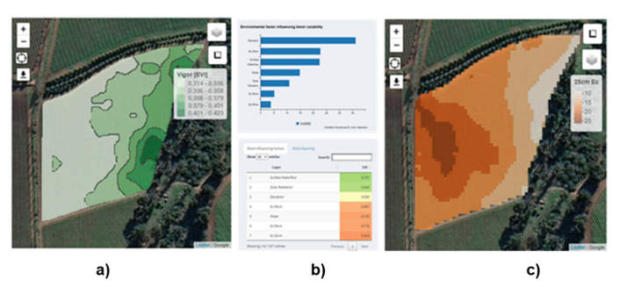
Figure 10. Revolute dashboard (Source: https://www.revolutesystems.com/) a) Vigor map generated by the Revolute team b) parameters used c) EC map generated for the 25cm depth.

Soil analysis
Soil samples were extracted at a depth of 50 cm, distancing 30 cm from the target vines for Trail 1 and 2. The samples were analysed at the Directorate Plant science of Elsenburg for texture, resistance, macro/micro-nutrients, exchangeable acidity, particle size and ammonium (NH₄).
Unit 5. Remote sensing:
Drone
Drone Multispectral imaging (Sequoia Multispectral sensor, 4 bands, 16Mpx camera) with a resolution around 5 cm/pixel were obtained during the season to characterize vine growth. An essential component of canopy growth is the development of leaf surface area relative to land surface area (Leaf Area Index - LAI). Newly developed algorithms and automated methodologies using digital imaging and drones will be implemented to determine the leaf area index (LAI) and other canopy structural parameters. A customized MATLAB code was used to filter the images and calculate projected canopy area calculation for each target site (Poblete-Echeverria et al., 2017).
Testing season (2020-2021) – optimization 1
During the testing season, a new protocol was tested to optimize the data acquisition. Drone images were taken in the middle morning to create shadow projection in the interrow space (Figure 11). This new methodology was implemented in collaboration with ITACyL (Instituto Tecnológico Agrario de Castilla y León), University of Leon, Span. The article that describes this new method will be published soon; it is under revision for publication in the journal OenoOne.
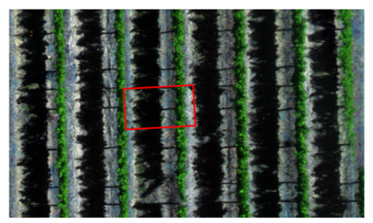
Figure 11. Example of the projected shadow in the interrow (Thelema 18 December 2020). In the testing season drone images were taken by Caelum Technologies using a Multispectral camera (MicaSense Red Edge TM3 Multispectral camera, Phantom 4 pro 20MP HD camera) with a resolution of 5 cm/pixel.

Testing season (2020-2021) – optimization 2
Image progressing (remote sensing approach)
Vine segmentation
The method used for vineyard segmentation and individual grapevine identification was done in QGIS (QGIS 3.16.8, Hannover) software by manually cutting/isolating target vines from RGB and multispectral images for Vegetation indices (VI) & fractional cover (fc) analysis. A polygon represented an individual vine with an area of 2.5m x 2m. Figure 12 briefly explains the process.

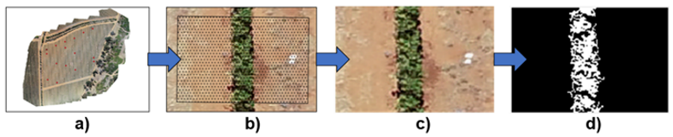
Figure 12. Image analysis 3-step flow diagram. Example of target vine P7, a) image taken 26 February 2021, b) 2.5 x 2m polygon for image cutting using white rock to identify middle of the plant c) cut image, d) black and white mask used to calculate fractional cover (fc).

Normalized difference vegetation index (NDVI) canopy fraction
NDVI values were calculated for the whole vine area (NDVI_{mean} - average of all pixels in the vine area representative polygon (2.5m x 2m) and for the canopy area (NDVI_{canopy}) considering only the canopy fraction. In this case, RGB-polygon was converted into a black and white mask using MATLAB colour thresholding app to isolate only the canopy fraction (f_{c}). The mask was used to isolate the canopy excluding the average calculation all soil pixels.

Statistical analysis
Basic descriptive analysis was done to calculate mean, minimum, maximum, standard deviation, coefficient of variation and person coefficient (R). R was evaluated to investigate suitability of methods to estimate leaf area/spatial variability compared to standard reference methods. A correlation analysis was performed to evaluate the strength of relationship between the references LAI, PW values and LLA, f_{c}, and NDVI_{mean} and NDVI_{canopy} and the result was presented as a correlation matrix. Data maps were generated using QGIS (QGIS 3.16.8, Hannover) and correlation maps were generated using SIMCA version 16.0.2 from MKS Data Analytics and Solutions).
Satellite
Landsat
Landsat-8 imagery (Operational Land Imager (OLI)) of the experimental site has been obtained via the United States Geological Survey (https://earthexplorer.usgs.gov/). OLI sensor provides imagery with 30 m spatial resolution in the visible to shortwave infrared wavelengths with a revisit time of 16 days. These images will be used to model the energy balance of the experimental site.
Sentinel
Sentinel-2A and 2B images of the experimental site have been downloaded from European Space Agency (ESA) Copernicus project website. The Copernicus Sentinel-2 mission is based on a constellation of two identical satellites in the same orbit. Each satellite carries an innovative wide swath high-resolution multispectral imager with 13 spectral bands providing images with a resolution of 10 meters.
Planet scope
Planet scope Planet operates more than 200 satellites that together provide a collection capacity of 350m km2/day. Planet scope satellite images were bought form planet labs with the support of Revolute. These satellites provide a spatial resolution of 3 m with 4 bands (R, G, B and NIR).
Additional experiments (Complementary information)
Outside of the original scope of this project, 3 additional pilot experiments were carried out using the site and logistics of the IVMS project. 1) Light Detection and Ranging (LiDAR) - Robotic project: During the first season, the LiDAR sensor, for 3-D canopy analyses (Poblete-Echeverria et al., 2018), was tested by a field experiment. The LiDAR scans were taken in whole rows on one side of the canopy at a 110 cm distance. LiDAR scans were done 3 times during the season. 2) Hyperspectral camera – Polariks: During the first season, an additional pilot experiment was done using a hyperspectral camera from Polariks (https://www.polariks.com/). Hyperspectral images were taken manually with the camera in one movement from both sides of the canopy for Trail 1 (conditions 2 and 3) to evaluate water stress conditions. For Trail 2 automated images were taken for all 43 target vines with the hyperspectral camera mounted on the Dassie Robot. 3) Vegetal Signal: In the past season a field experiment was done to test the Vegetal signal sensors in Trial 1. The performance of the VS sensors was assessed by comparison with standard measures (Stem water potential and stomatal conductance) from December 2020 to February 2021. This activity was part of the innovation program of Winetech.
Methodology used at harvest (Season 1 and 2)
All target vines (Trail 1 and Trail 2) were harvested 1 day before the commercial harvest of the block, with an average 23.8 Brixº for the entire block. All bunches were carefully handpicked. Each target vine was analysed individually for the following variables: Total vine weight (TVW), Bunch counting (BC) and Bunch weight (BW).
Testing season (2020-2021) - optimization
In the testing season due to extensive rain, Thelema harvested their commercial grapes 2 weeks after our experimental harvest. Harvested grapes were 20.6 Brixº on average at harvest. In the optimized harvest protocol, each target vine was individually harvested to obtain the total kg per vine. For each individual bunch weight, multispectral image and volume displacement was taken (Figure 13).

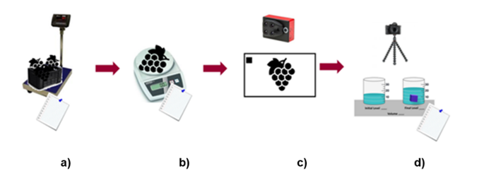
Figure 13. Harvest protocol testing season. a) Crate weight b) Individual bunch c) Multispectral images d) Volume displacement.

Fruit analysis
Chemical analysis
Juice was collected after crushing the berries for each of the target vines in Trail 1 and 2. The juice was immediately analysed to determine Sugar (PAL-1 Digital Pocket Refractometer, Atago, USA), pH, TA (Metrohm, model 702 SM Titrino, Switzerland) and also Nitrogen (Bruker, MPA II Multi-Purpose FT-NIR Analyzer, UK).
Physical analysis
RGB and multispectral images were taken of all bunches for each of the target plants for Trail 1 and 2. With these images, we calculated the total volume/weight per plant. This is very important for yield estimation. For this measurement, we use the Canon RGB camera (black) with a 32GB SD card and a small white panel as well as a multispectral camera (Sequoia Multispectral sensor, 4 bands, 16Mpx camera). The RGB images in combination with the bunch weights and volume displacement will be used to set up correlation for yield estimation. The RGB images will be processed in MATLAB and the total area cm2 will be used in the correlation estimates. 50 berries were collected from 3 separate bunches per vine for each of the target plants in Trail 1 and 2 and photographed. The RGB-image was processed in MATLAB for berry size differences. Multispectral images can also be used to evaluate stress signals in the bunches.
Reference data
Reference data was collected for all target vines (Trail 1 and Trial 2) which included total vine weight (TVW), amount bunches (BC), individual bunch weight (BW) and volume displacement.
Microvinification
All harvested grapes were kept at 4 degrees until physical harvest measurements were complete. In the cellar, the grapes from each target vine were kept separate. The grapes were completely stripped from the rachis and homogenised before a CONSOL jar was filled with a representative 2kg batch (Figure 14). These berries were hand-crushed for 60 seconds to keep phenolic extraction at the same level. The juice was inoculated with Saccharomyces cerevisiae (ICV D21, Lallemand, France) and a blended complex yeast nutrient (Fermaid K Lallemand France) was added to prevent sluggish fermentation. Wines were fermented at 23ºC with two punch downs daily. Alcoholic fermentation was monitored by weight loss, once weight loss was stable the wines were seen as dry (< 2.5g/L). The final wines were sulphured and frozen as wine samples for analysis.
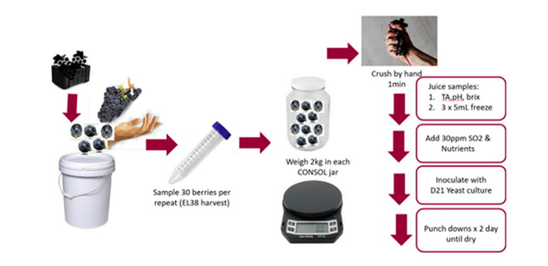
Figure 14. Visual representation of the winemaking protocol that was implement during the testing season.

Phenolic analysis
The phenolic compounds were calculated using spectrophotometric analysis with a Multiskan GO Microplate Spectrophotometer (Thermo Fisher Scientific, Inc., Waltham, MA, USA). This activity was done with the support of the PhenoLab.
Pruning weight (Winter period)
All the target vines for Trial 1 and Trial 2 will be pruned mid-August. Shoots will be collected, and standard pruning weight will be taken. Ravaz Index (RI), the ratio of yield to pruning weight, will be used to evaluate vine crop load (Smart and Robinson, 1991). For the testing season, pruning weight was done in August.
Smoke taint (Complementary)

Due to fires close to the selected research site in February 2021, a smoke taint profile was done on the juice samples obtained at harvest. The analysis was performed by the Central analytical facility (CAF), Stellenbosch University for Volatile Phenols with GC-MS. The method used was proposed by Mckay et al., (2019) and it allowed the quantification of the 12 compounds related to smoke taint.

7. RESULTS AND DISCUSSIONS

Results and discussion - Objective 1 & 2
Site selection
In Season 1 (2019-20) the integrated monitoring system (IVMS) was established in the block “W1B”, Thelema Mountain Vineyards, Stellenbosch. Block information supplied in Table 2. The historical average yield in the block was noted as 8.24 Ton/ha with an average of 4.0 kg/vine. The block was managed by the producer as being homogeneous. In Season 1 (2019-20) 43 target vines were selected for Trail 2 and additional 12 vines allocated for Trail 1. After the initial testing season, it was clear that 3 water classes could be established across the block using weekly stem water potential readings (Jasse et al., 2021). According to these classes the initial 43 vines (Trail 2) were decreased to a total of 33 vines representing in the different classes. Harvest data per vine is shown in Table 3. In both years the coefficient of variance was above 30% already indicating that the block was in fact heterogenous.

Table 2. Thelema Mountain Vineyards experimental block
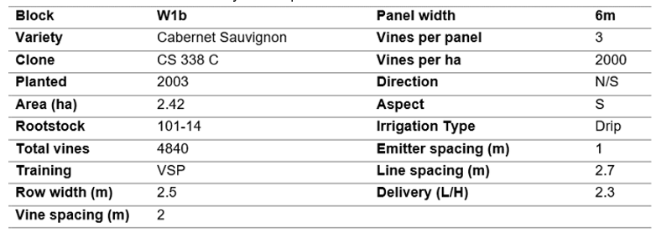

Table 3 Harvest data for 2 consecutive seasons.
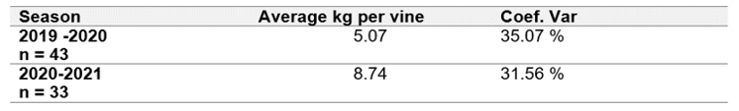

Testing season Optimization (Trail 1)
Water stress (WS) was induced in a section of the block by implementing dryland irrigation from the beginning of the season until harvesting. In the 2019/20 season, the non-stressed/fully irrigated (FI) vines were watered according to the irrigation schedule implemented at the farm. However, in the 2020/21 season, the commercial irrigation schedule was further supplemented by applying 25 - 50 L of irrigation per week to each of the FI vines to ensure that the midday Ψstem remained below the -0.9 MPa threshold. The FI group was also changed in the second season to another location in the field with naturally less negative Ψstem (based on meta data from Jasse et al., 2021) to enhance difference in water status between the groups in the 2020/21 season. Figure 15 shows the weekly Ψstem for the 3 groups of vines according to the above-mentioned water regime that was successfully implemented.
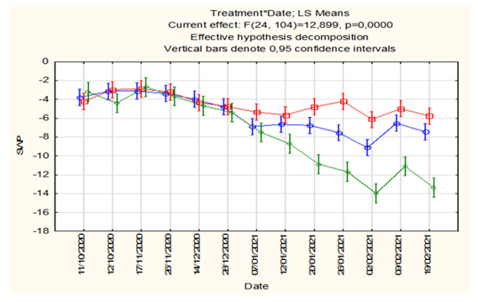
Figure 15. Validation results of the optimization of Trail 1. Blue line indicates condition 1 commercially irrigated, Red line indicates condition 2, double irrigation and Green line indicates condition 3, dryland scenario.

Water use efficiency
Water use efficiency (WUE) was calculated for season 1 and 2 as a ratio between yield and the volume of water provided in each condition through irrigation and rainfall (Pérez-Álvarez et al., 2021). This summary is shown in Table 4. In season 1 and 2 the commercial and double line irrigation showed similar trends with double line being slightly higher. Dryland however had the lowest WUE (kg/m³). The data clearly indicates that the strategic/controlled addition of irrigation at correct times does have a positive impact on the overall WUE with the added water contributing to an increase in production and therefore profit compared to dryland irrigation.

Table 4 Summary of the WUE (kg/m3), yield, total irrigation, and rainfall for Season 1 and 2 for the different irrigation conditions.
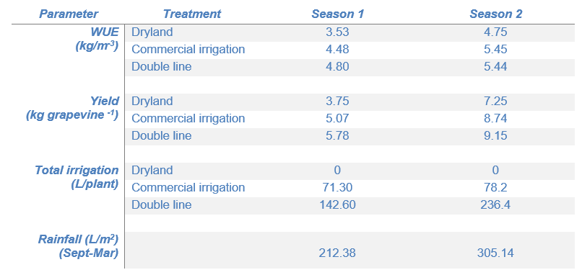
IVMS Monitoring units

To analyse the experimental vineyard in a comprehensive way, five monitoring units were established: Micrometeorological (Unit 1), Meso and microclimate (Unit 2), in-vine monitoring (Unit 3), in-soil monitoring (Unit 4), and Remote sensing (Unit 5). Field measurements consisted of once-off, weekly as well as monthly measurements during the growing season. Table 5 gives a short description of each monitoring unit and the variables measured to produce the data output.

Table 5. IVMS Monitoring unit’s Variable summary

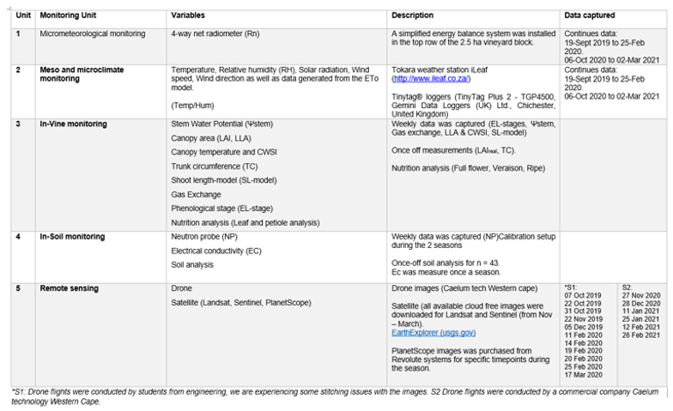

Water stress monitoring
Midday stem water potential (Ψstem) was used as reference method to define the water status of the vines (Trial 1 and 2). Ψstem was compared to alternative methods and used as a guide to perform water stress classifications.

Classification of the vines according to the vine water status
From the Ψstem measured values along the season, plants were grouped according to level, period, and duration of the waters stress in 3 classes: i) Class 1 - low water deficit, ii) Class 2 - moderate water deficit and iii) Class 3 - severe water deficit (Figure 16).

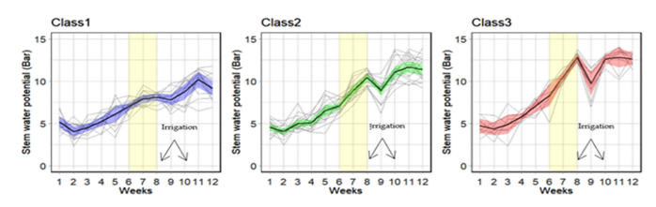
Figure 16. Classification of stem water potential variability along 2019 season, with Veraison starting in week 7 and two irrigation events. (Figure extracted from Jasse et al., 2021).

Plants in Class 1 have a more homogeneous variation along the season, with a low amplitude of SWP values from week 1 to week 12. On the other side, plants from Class 3 presented a greater amplitude of SWP during the season.

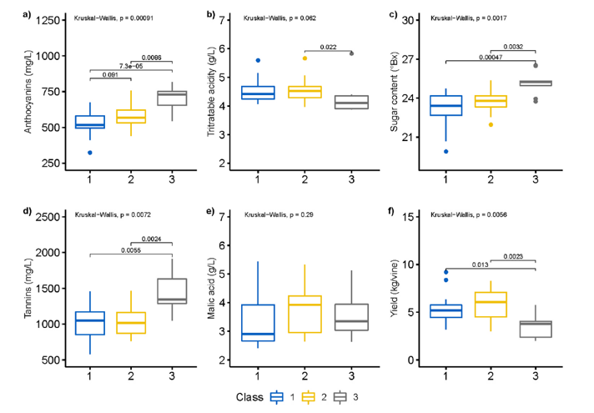

Figure 17. Box plots for juice and wine phenolic analysis. a) Anthocyanins, b) Tannins, c) Malic acid (expressed in g/L), d) Acidity (expressed in g/L), e) Sugar concentration, and f) Yield. (Figure extracted from Jasse et al., 2021).

The progression of water deficit in the plants until Veraison is similar to all classes, however between week 6 and week 8 (Veraison period) the plants in Class 3 rapidly reached the point of severe water deficit. This trend in Class 3 was only diminished for a week, with the first irrigation event, to return rapidly to the same level of water deficiency until harvest. It is also apparent that the irrigation events had a lighter effect on SWP variability in Class 2 than in Class 3, where vine water deficit was severely affected. The impact of the irrigation events and recover of water content within plants with severe water deficiency was evident by the decrease of SWP values after the irrigation events.
The box plots presented in Figure 17, gives an indication of the dispersion of the variables inside the classes and the statistical differences between classes (LSD test). No statistical differences among the classes were registered for malic acid and total acidity. From the other side, the analysis of Anthocyanins, Tannins, Sugar concentration and Yield, presented significant statistical differences for Class 3. For anthocyanins, Class 3 was significantly higher than Class 1 and 2. The positive skew in Class 3 reveals that 50% of the observations in this group were higher than 711.1 mg/L (Table 6). Likewise, Tannins presented significantly higher values in Class 3 (Figure 17b). However, Class 3 demonstrates a much smaller 2nd quarter, indicating that 50% of the plants presented value superior to 1427.7 mg/L and a higher mean value of 1911.2 mg/L (Table 6). The sugar content distribution in the classes was consistent for Class 1 and 2, however, Class 3 box plot is significantly higher and the value range very slim with values ranging from 23.7°Brix to 26.5°Brix (Table 6). The yield of the plants in Class 3 was significantly lower than the yield in the remaining groups. In fact, 50% of the plants in Class 3 had a yield lower than 3.56 kg/plant. From the other side, more than 75% of the plants in Class 1 and 2 had a yield superior to 4.26 kg/plant.

Table 6. Distribution of physiological, chemical, and phenolic characteristics in 3 different classes. (Table extracted from Jasse et al., 2021).
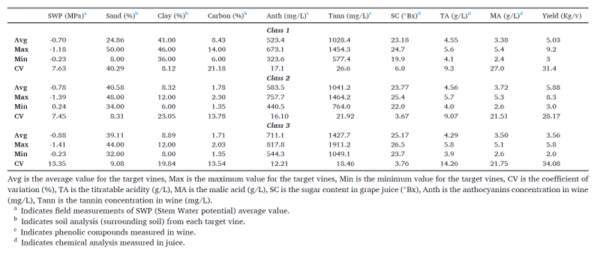

Evaluating SWP variability for Trail 1
For both seasons there was a clear trend that the water stressed (WS) vines had higher levels of stress compared to the Full irrigated (FI) vines. The g_{sw} for WS treatment ranged from 0.05 - 0.09 molH₂O/m²/s while those under FI ranged from 0.09 - 0.25 molH₂O/m²/s across the phenological stages (Figure 18).
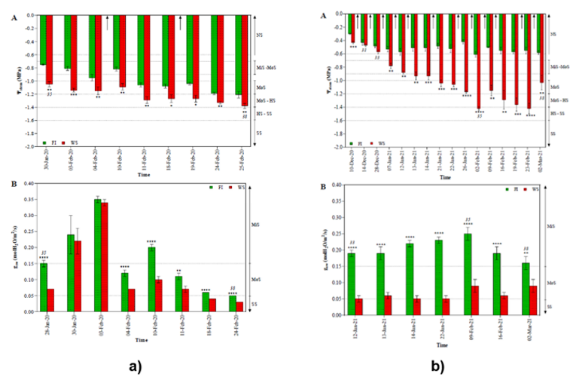
Figure 18 Midday Ψstem and g_{sw} of Cabernet Sauvignon under FI (full irrigation) WS (water stress) treatments in the a) 2019/2020 season and b) 2020/2021 seasons. EL stages are indicated by the number in italics and EL21: pea size berry, EL 33; hard green berry, EL 35: Veraison, EL 38: harvest ripe. Arrow indicates irrigation events. Asterisk *, *** and **** represent t-test results for p< 0,05, P< 0,01, p< 0,0001 respectively. Values presented are treatment means +- standard error and n = 4, NS = no stress, MiS =mild stress, MoS = moderate stress, HS = high stress, SS = severe stress. Extracted from Stenford Matsikidze PhD Thesis (March 2022).

Thermal response of Vines (CWSI) Trail 1
Canopy temperature (Tc) is defined as the average of the plant’s leaf temperature distribution. With IR cameras, this temperature is approximated by taking the average temperature of the leaves in the FOV of the sensors. For a correct application of temperature as an indicator of water stress Tc values must be normalized to consider the instantaneous environmental conditions of the measurement. The standard method to implement this normalization is the crop water stress index (CWSI).
Figure 19a presents the correlation between SWP and canopy temperature on the different days. There are strong correlations between the variables on any given day (r2 ranging from 0.41 to 0.95), but in general, over all the days, there is no correlation. The results agree with Gutiérrez et al. (2018) that indicate that the correlation between CWSI and SWP is greater on any given day than when days are combined, but individual days provide little information and days should always be combined. It is noted that there is a definite change in the slope of the curves after 2 February. This coincides with the phenological stage of veraison, where the plant changes focus from using energy for plant growth to berry growth. The data is therefore split into two groups: pre-veraison (Stage II) and post-veraison (Stage III). The CWSI in the different stages is presented in Figure 19b. Fernandes de Oliveira et al. (2021) found a similar change in grapevine thermal response and suggests that as the phenological stages progress, lignification along the main shoot causes variation in water transport along the main shoots of the vines.

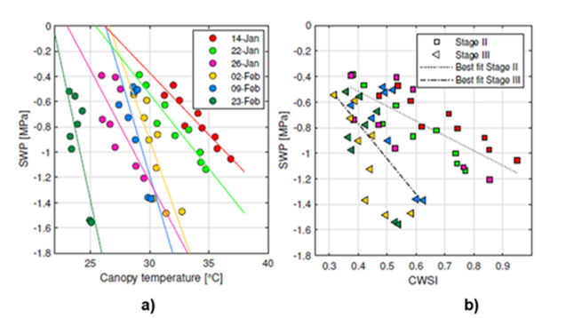
Figure 19. a) Scatter plot of SWP vs Tc and b) SWP vs CWSI for the C3, with a white panel at 2nm, on the sunlit side at 12:00. The colour legend of a) applies to b) as well. (Extracted from Jaco Luus MSc Thesis 2021).
Further to the above correlations between stomatal conductance (g_{sw}) and vegetation indices (CWSI) was evaluated in Matsikidze 2022. The Thermal vegetation indices (TVIs) had highly significant correlations (p < 0.05) with g_{sw} in both seasons (Table 7). In the 2019/20 season, the correlations between g_{sw} and TVIs were significant (p < 0.05) for all the indices, and the coefficient of correlation was highest between g_{sw} and ΔT (r = -0.73), followed by CWSI (r = -0.57) and Ig (r = 0.50). The 2020/21 season results also indicated that the correlations were significant (p < 0.05) between g_{sw} and all the TVIs and the highest correlation coefficient was between g_{sw} and CWSI (r = -0.84), followed by Ig (r = 0.78) and ΔT (r = -0.78) had similar correlation coefficients to g_{sw} in the 2020/21 season. The relationship between g_{sw} and the TVIs for the combined seasons (2019/20-2020/21) also showed significant (p < 0.05) relationships between gsw and TVIs. The CWSI had the strongest correlation (r = -0.83) to g_{sw}, followed by Ig (r = 0.79) and ΔT (r = -0.76).

Table 7 Correlation analysis between stomatal conductance and thermal vegetation indices.
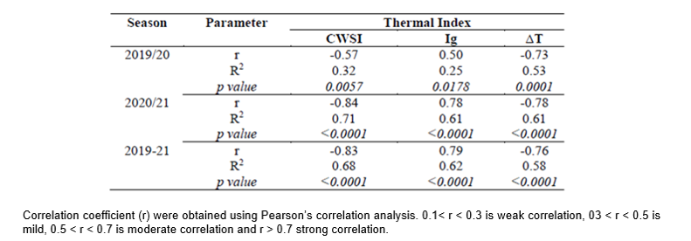

Evaluating SWP variability for Trail 2
Results summarized in Figure 20 indicates Midday Ψstem measured for season 1 a) Week 1 – 13 ranging from 05 November 2019 to 25 February 2020. Season two b) Week 1 -14 ranges from 10 November 2020 to 02 March 2021. Figure 20c and d shows the spatial map of the average Ψstem for each season respectively. The spatial patter for both seasons are in-line with the class distribution (Jasse et al., 2021).
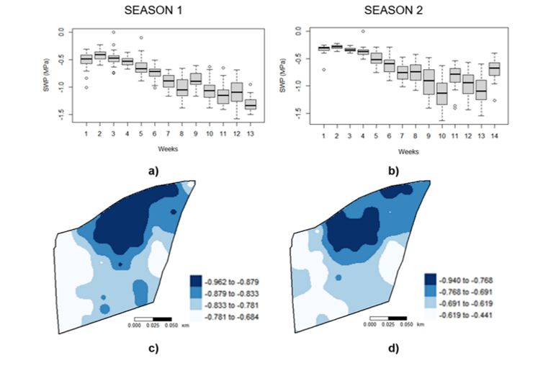
Figure 20 a) and b) average midday Ψstem measured weekly for each season. Boxplot indicates the spread/distribution of measurements between target vines per weekly reading. c) and d) shows spatial maps representative of the average midday Ψstem for each season.
Evaluating Volumetric water content for Trail 2
Weekly neutron probe (NP) measurements were converted to soil water content by setting up the relevant gravimetric soil calibrations for 2 soil depths 0 - 20cm and 20 - 40cm. Figure 21 shows average spatial mapping of soil water content for both seasons for 0-20 cm (a and b) and 20-40 cm (c and d) respectively. Spatial trends are in-line with water classes as well as average Ψstem trends with dark blue (high volumetric water content areas) corresponding to areas having lower Ψstem values.
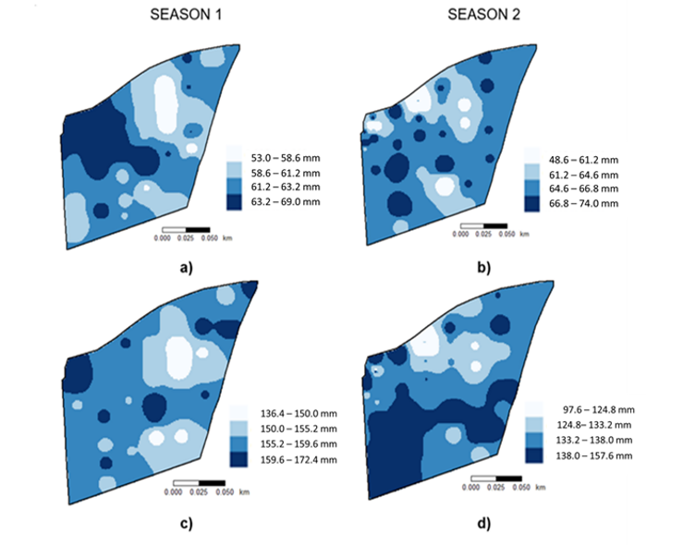
Figure 21 a) and b) average volumetric water content measured weekly for each season at 0-20cm depth. c) and d) shows spatial maps representative of the average volumetric water content for each season measured at 20-40cm depth. Colour scale ranging from light to darker with the increase in soil water content.
Canopy characterisation
Canopy characterisation can give an indication of the plant size, vigour status, density/porosity and even the plant-soil-water relations. The canopy leaf area is seen as the total area that can intercept light, providing an indication of the plant’s photosynthetic capacity and transpiration (Dobrowski et al., 1994). The leaf area will have a direct impact on the microclimate in the canopy in terms of temperature, radiation, wind, humidity, and light interception. This will determine the grape composition and ultimately the final wine quality (Smart, 1985; Dokoozlian & Kliewer, 1995; Alem et al., 2019 and Gutiérrez-Gamboa et al., 2021). In light of the previous mentioned aspects and the tremendous increase in non-invasive digital technologies to address or replace old-fashioned destructive measurements, focus was placed on optimizing methods to characterise vine performance/canopy by making use of different remote and proximal sensing techniques compared to industry standard Leaf area index (LAI) reference method to evaluate the use as possible monitoring tools for vineyard variability/variation.
Due to different types of “conditions” (shadows, soil, cover crop etc.) in the canopy it becomes challenging to have a standardized method that can be applied to characterize canopy area. Canopy characterization therefore is informative, but estimation process remains very difficult especially in a large field setup. These conditions give rise to different methodology of estimating/characterizing leaf area (LA). Available methods are usually dived into two main categories to estimate LA 1) Direct methods and 2) Indirect methods. Direct methods consist of measuring leaf area in a direct way as a ground-based measurements and unfortunately destructive. These are however seen as the most precise methods, but they have the disadvantage of being extremely time-consuming and therefore only marginally feasible as they cannot be upscaled to big experimental designs. Indirect methods consist of methods where leaf area is inferred from observations of another variable. Optical methods as indirect non-contact methods are commonly implemented. They are based on the measurement of light transmission through canopies, and they are generally considered faster, amendable to automation, and thereby allow for a larger spatial scale or experiment to be obtained (De Bei et al., 2016).
In this project we proposed the below mentioned methodologies for characterizing the vineyard canopy (Table 8).

Table 8. Summary of proposed methodologies to characterize grapevine canopy as a monitoring tool.
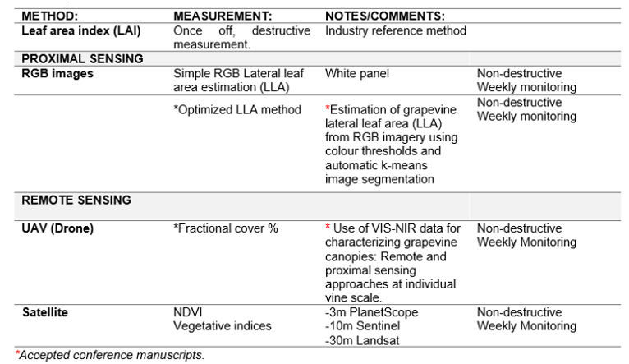

Proximal sensing:
Figure 22 shows and example of Simple RGB-image LLA estimation Season 1 for three developmental stages a) Full flower (F_LLA), b) Veraison (V_LLA) and c) Ripe (R_LLA). This method was able to distinguish between different size canopies and the spatial map also compliments water monitoring data were low Ψstem values and high volumetric water content correlates with bigger LLA.

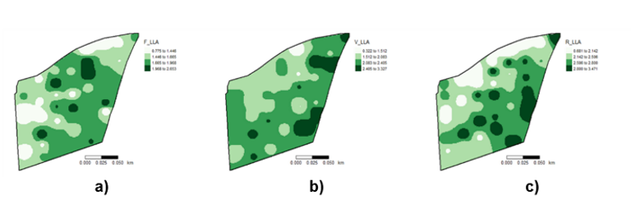
Figure 22. Inverse Distance Weighing (IDW) was used to generate maps n = 43 in R Studio® IDE (version 4.0.2, RStudio, Boston, MA, USA) to follow the spatial change for LLA during the season. a) Full flower (EL-25) b) Veraison (EL-35) c) Ripe (EL-38).

By implementing the optimized LLA method the accuracy of estimating LLA compared to the reference was increase by using the HSV color space (Figure 23a). Combining the HSV color space with k-means when segmenting ultimately gave the best results (Figure 23b) (Berry et al., 2021).
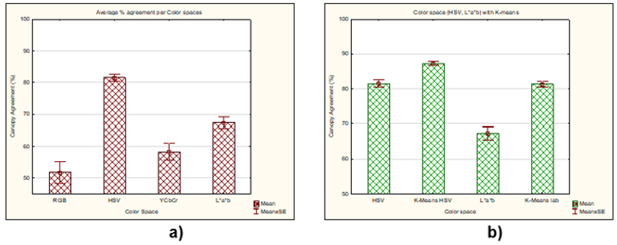
Figure 23 a) Average % agreement between the 4 color spaces from step 2 (RGB, HSV, YCbCr and L*a*b). b) Average comparison between HSV/L*a*b vs automated K-means HSV/L*a*b.

The success of this image segmentation is specific to the application on VSP trellis systems. Compared to traditional methods and normal RGB -image segmentations, this novel approach transforms RGB-images into color spaces where unwanted pixels can be excluded and therefore offers a non-destructive, time-saving application that can be implemented in field studies to generate maps on the evolution of within-vineyard variability.
Remote sensing:
UAV Drone fractional cover determination
In Figure 24 a comparison is showed between the spatial maps for n = 16 target vines for a) Leaf area index (LAIr) reference method, b) LLA and c) fractional cover (fc) determined from the UAV images. This method showed that suggested proximal- remote sensing methods can be used as a guide to detect differences in canopy size. Although fc performed better than the estimation by LLA the combination is recommended. These non-destructive methods can be further upscaled to include more vines to increase the accuracy of management zone identification as well as monitoring spatial variability during the season. The relationship between 2D LLA and 2D fc compared to LAIr can also be further investigated.

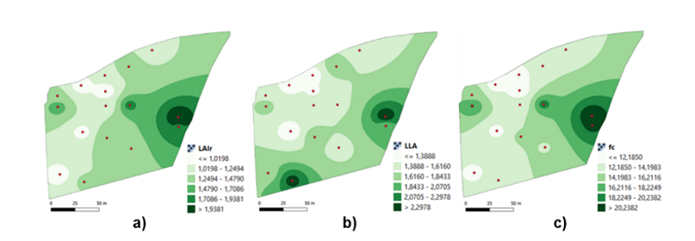
Figure 24. Inverse Distance Weighing (IDW) was used to map n = 16 LAI_{real}, LLA and fc to compare zones. a) The real lateral leaf index (LAIr) b) Lateral leaf area (LLA) c) fractional vegetation cover (fc). Extract from poster presented at: International Symposium on Vitiviniculture Sector: Which tools to face current challenges 14 -20 August 2022, Angers (France).

Satellite images - Normalized vegetation index (NDVI)
Sentinel satellite images were downloaded for the whole growing season. The standard normalized vegetation index (NDVI) was calculated as a vigour indicator. Figure 25 present an example of NDVI data and its distribution from November 2020 to February 2021.The data converted into relative frequency histograms (Figure 25a), show that November presented the highest NDVI values which in this case could be due to the inter-row effect (cover crop). December to February shows the same trend which is reflective of the canopy growing as the season progressed and the cover crop dying with most of the values in the range of 0.35 to 0.40. The same data is visually represented in Figure 25b where the changes in vegetation growth can be seen also highlighting the spatial variability within the block.
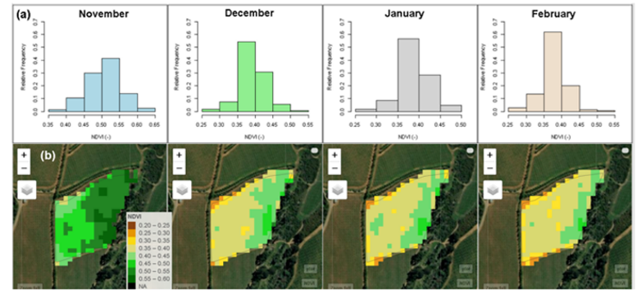
Figure 25. Satellite image analysis. a) relative frequency histograms, and b) NDVI variability maps.

Additionally point extraction of spectral indices was performed on all n = 43 target points for satellite images obtained from PlanetScope (3m), Sentinel and Landsat 30m.Figure 26 is an exam ple of the average NDVI, GNDVI, NGRDI and SAVI calculated over the season for each target vine (n = 43) for season 1 and 2 using the 3m PlanetScope satellite image.

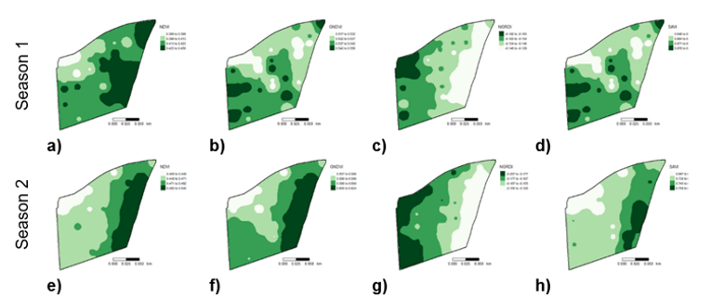
Figure 26. Inverse Distance Weighing (IDW) was used to map spectral indices extracted from 3m PlanetScope satellite images for n = 43. a and e) NDVI, b and f) GNDVI c and g) NGRDI and d and h) SAVI for season 1 and 2 respectively to compare zones.

Complimentary to canopy characterisation is nutrition information that was obtained by leaf disk analysis at three developmental stages during the 1st growing season. Table 9 summarizes the basic descriptive analysis done on the nutrient analysis for leaf disks analysed at ripe stage (EL-38). Except for Organic Carbon that had a low % CV of 1.94 % all the other elements had CV % of between 19.37 -32.27 % ranging extensively between minimum and maximum values. Macro-nutrient trends are in accordance with literature showing decreasing patterns for N, P and K while Ca and Mg increased during the season (Romero et al., 2010).
Table 9. Statistical summary of leaf disk nutrients measured at harvest (Ripe) for n=43

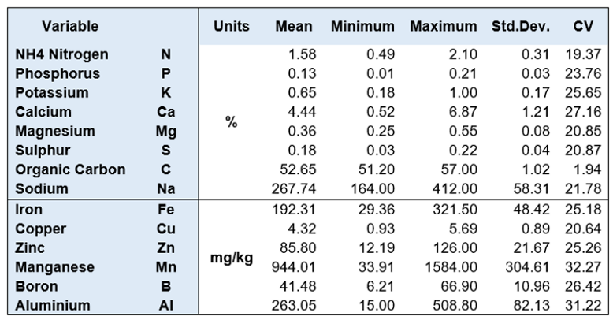

Nitrogen has an important role in vine balance and grape composition. Figure 27 maps the nitrogen variability observed during the season for analysed petiole (full flower), leaf disk (Veraison & Ripe) as well as resultant YAN measured in the grape juice. Marking a decrease in concentrations from Veraison to Harvest. Although Nitrogen is a complex topic some deductions can be made. Nitrogen concentration showed the highest CV of 19.37 % during the ripe stage ranging from 0.49 - 2.10 dry weight. It is known that nitrogen can play a role in delaying the ripening process due to growth being stimulated to the disadvantage of sugar accumulation (Spayd et al. 1991). This trend is also displayed with higher nitrogen areas also reflecting larger LLA values. Higher levels of nitrogen have also been seen to affect colour development (Delgado et al., 2004; Keller 2010).

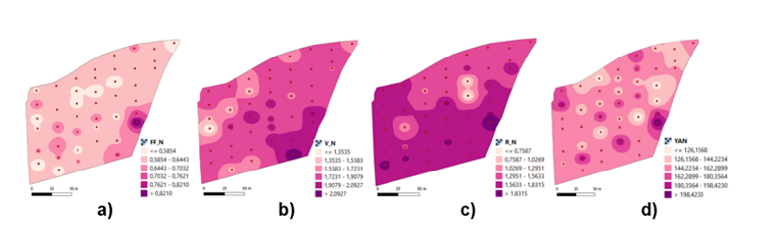
Figure 27. Inverse Distance Weighing (IDW) was used to generate maps in QGIS (QGIS 3.16.8, Hannover) to follow the spatial patterns of nitrogen during the season compared to YAN analysed in the final grape juice at harvest. a) Nitrogen % at full flower measured in the petioles. b) Nitrogen % measured in the leaf disks at veraison c) Nitrogen % measured in the leaf disks at harvest (Ripe) d) YAN measured in the grape juice at harvest.

YAN concentration thresholds guarantee proper alcoholic fermentation kinetics with YAN < 140mg/L holding a risk of incomplete/stuck fermentation (Bell and Henschke, 2005). The target vines showed variation CV of 15.65% with values ranging between 104.30mg/L to 216.53mg/L (Table 10). Sugar accumulation also tends to be lower in berries with higher YAN levels which is reflected also in this study. Grape quality indicator parameters are summarized in Table 10. High variability is seen in yield (kg per vine) as well as sugars ranging from 18.50 -27.50 ºBrix across the experimental block. Visual representation of spatial trends can be evaluated in Figure 28.
Grapevine production is economically driven, placing pressure on farmers to produce quality grapes (Gutierrez-Gamboa & Moreno-Simunovic, 2019). Spatial variations between grape juice quality indicators such as sugar, titratable acidity (TA), pH and phenolics are common parameters measured to define wine grape maturity and quality and have been reported in several studies (Bramely 2005; Baluja et al. 2012; Trought and Bramley 2011; Alexandersson et al. 2014). These authors suggested that the addition of crop phenology would be advisable to optimize selective harvesting, as grape composition showed variation across the ripening period.
If the spatial variations are not properly managed it can be detrimental to the resulting wine quality. The variability can be seen at different scales. At the vine level, the lack of quality can be attributed to an asynchronous berry development that has consequences for quality due to a percentage of berries with optimum qualities diluted by those that are lower in quality when harvested together (Coombe and Iland, 1987).
Intra-block variability can largely be attributed to soil, topography and climate change having a major impact on yield and final grape composition (van Leeuwen & Seguin, 2006; Bramely et al. 2011). The mapping thereof can greatly benefit our knowledge regarding variability. As a result, it is also worth assessing the nutritional status of the grapevine to determine unbalanced fertilization which can lead to undesirable effects on grapevine growth (vigour) and grape composition as it has also been noted that vine vigour can have an impact on yield as well as quality (Trought et al. 2008, Trought and Bramley 2011).
Table 10. Descriptive analysis of Lateral Leaf area (LLA) as well grape juice parameters measured at harvest on grape berry juice for n=43 and anthocyanins analysed on the final wine.
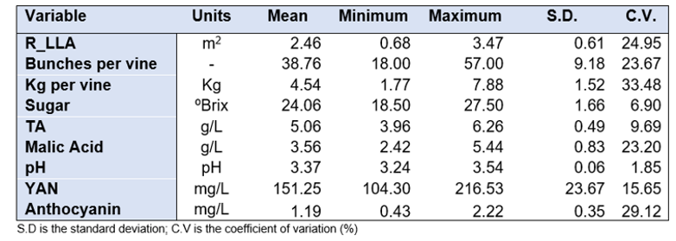

The advances in precision viticulture techniques allow the mapping of several soil, and viticulture parameters. In a recent review by Sassu et al. (2021) spatial mapping is shown to be used for several research aims ranging from spatial variation of vine vigour, phenolic maturity, vegetation indices, mapping of leaf carotenoid concentration, leaf chlorophyll, to canopy biophysical and geometrical characteristics to name a few (Sassu et al. 2021; Matese et al. 2013; Zarco-Tejada et al. 2013; Caruso et al. 2017; Pádua et al. 2020). In this context, mapping the spatial variability inside of a vineyard block can not only allow the identification of management zones that can either be sequentially harvested (homogeneous quality) or be managed by precision viticultural techniques but also allow exploring of possible trends contributing to these zones. Therefore, the objective was to explore the effect of within-vineyard vine spatial variability on canopy size and grape juice parameters (Figure 28 a – g). Descriptive statistics are given in Table 10.

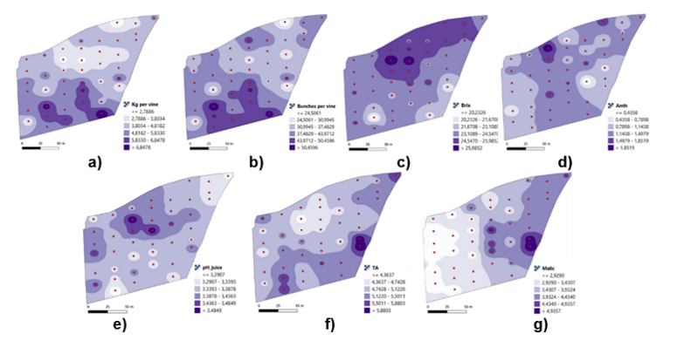
Figure 28. Inverse Distance Weighing (IDW) was used to generate maps in QGIS (QGIS 3.16.8, Hannover) to evaluate spatial patterns of juice analysis. a) Kg per vine b) Bunches per vine c) Sugar (Brix) d) Anthocyanin e) pH f) Titratable acidity (TA) and g) Malic acid.

A) Micrometeorological, Meso and Microclimate
Climatic conditions and phenology
The microclimate of the target vines was characterized using mini sensors (Tinytag). The accumulated growing degree days (GDD) were determined for the 14 target vines as well as for the standard weather station to compare the particular conditions of each site with the general condition of the block (Meso-climate).
The results show that general GDD data is much lower that than the target vines indicating that the microclimate in the bunch zone differs from the ambient temperature (Figure 29). In comparison to the previous season the top of the block consistently has higher temperatures (P2, P7, P14, P34) than the bottom part of the block that might be explained by the topography and slope this can also be seen in the spatial GDD maps Figure 30.
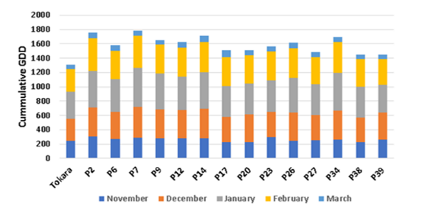
Figure 29. Accumulated growing degree days for each of the 14 target vines measured from November 2020 to 1st week in March 2021.

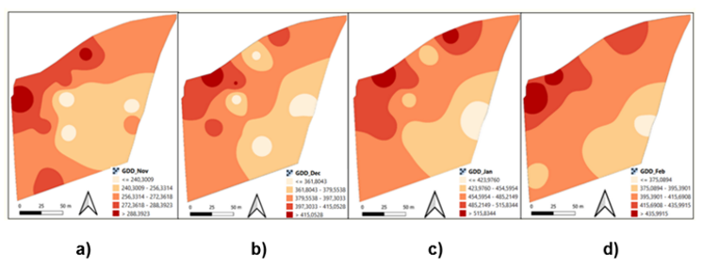
Figure 30 Calculated growing degree days for a) November, b) December, c) January, and d) February for Season 2 (2020-2021) n = 14 to map the microclimate (Bunch zone) of the block.
The phenological growth curves of seasons 1 and 2 were consistent showing a similar trend (Figure 31). Variability is more visible between target vines early in the season until Veraison when EL stage 35 is reached (red line in the figure), and sugar monitoring becomes necessary to monitor further ripening. When both seasons are compared, we can notice a delay of around 14 days in Season 2 with Veraison reached at week 11.
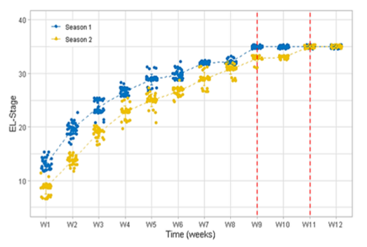
Figure 31. Phenological growth curve for Season 1 and 2.
Objective 3: Integrated data analysis and final report.

To summarize the output and suitability of multiple technologies that were tested for the monitoring of the response of vines to water deficit, and mapping of variability considering spatial and temporal variability Table 11 was compiled.

Table 11. Summary to show which methodologies can be used for spatial and temporal mapping when evaluating variability.

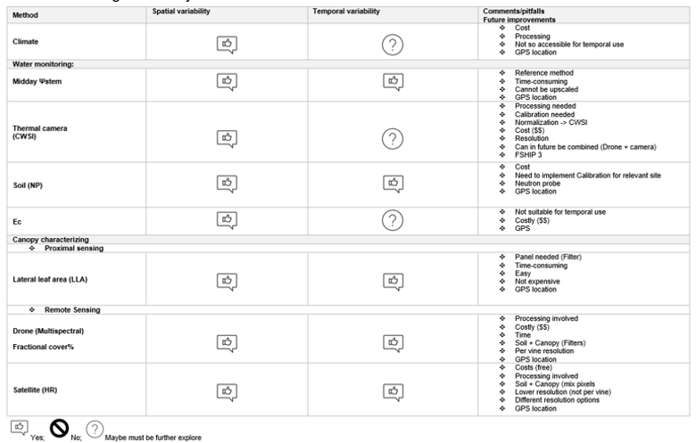

References

1. Alem, H., Rigou, P., Schneider, R., Ojeda, H., & Torregrosa, L. (2019). Impact of agronomic practices on grape aroma composition: a review. Journal of the Science of Food and Agriculture, 99(3), 975–985. https://doi.org/10.1002/jsfa.9327
2. Alexandersson, E., Jacobson, D., Vivier, M. A., Weckwerth, W., and Andreasson, E. (2014). Field-omics - understanding large-scale molecular data from field crops. Front. Plant Sci. 5, 286.
3. Baluja, J., Tardaguila, J., Ayestaran, B., Diago, M.P., 2012. Spatial variability of grape composition in a Tempranillo (Vitis vinifera L.) vineyard over a 3-year survey. Precis. Agric., 1–19.
4. Bell, S.-J. & Henschke, P.A. (2005). Implications of nitrogen for grapes, fermentation and wine. Australian Journal of Grape and Wine Research, II, 242-295.
5. Berry, A., Vivier, M.A & Poblete-Echeverria, C. Simple method for lateral leaf area (LLA) estimation of grapevine canopies using colour threshold and image segmentation. Oral Presentation. October 31 – November 5, 2021, Stellenbosch (South Africa): XI International Symposium on Grapevine Physiology and Biotechnology.
6. Bramely, R. G. V., 2005. Understanding variability in winegrape production systems. 2. Within vineyard variation in quality over several vintages. Australian Journal of Grape and Wine Research, 11, 33-42.
7. Bramley, R. G. V., Ouzman, J., & Boss, P. K. (2011). Variation in vine vigour, grape yield and vineyard soils and topography as indicators of variation in the chemical composition of grapes, wine and wine sensory attributes. Australian Journal of Grape and Wine Research, 17, 217–229.
8. Caruso, G., Tozzini, L., Rallo, G., Primicerio, J., Moriondo, M, Palai, G., Gucci, R. 2017. Estimation Biophysical and Geometrical Parameters of Grapevine Canopies (“Sangiovese”) by an Unmanned Arial Vehicle (UAV) and VIS-NIR Cameras. VITIS J. Grapevine Res., 63-70.
9. Chone, X.; van Leeuwen, C.; Dubourdieu, D.; Gaudillere, J.P. (2001). Stem water potential is a sensitive indicator of grapevine water status. Ann. Bot. 87, 477–483.
10. Coombe, B. G., and P. G. Iland. Grape berry development. In: Proceedings of Sixth Australian Wine Industry Conference, Adelaide. T. H. Lee (Ed.) pp 50-4 (1987). 47.
11. Delgado R, Martín P, del Álamo M, González M-R. Changes in the phenolic composition of grape berries during ripening in relation to vineyard nitrogen and potassium fertilisation rates. J Sci Food Agric, 2004; 84: 623-30.
12. Dobrowski, S. Z., Ustin, S. L., & Wolpert, J. A. (1994). Remote estimation of vine canopy density in vertically shoot- positioned vineyards : determining optimal vegetation indices. Vi, 117–125.
13. Dokoozlian, N. K., & Kliewer, W. M. (1995). The light environment within grapevine canopies. II. Influence of leaf area density on fruit zone light environment and some canopy assessment parameters. American Journal of Enology and Viticulture, 46(2), 219–226.
14. Dry, P., & Coombe, B., eds. (2004). Viticulture 1 – Resources, 2nd Ed. "Revised version of grapevine growth stages – The modified E-L system". Winetitles, Adelaide, Australia.
15. Fernandes de Oliveira, A.,Mameli, M.G., Lo Cascio, M., Sirca, C. and Satta, D. (2021). An index for user-friendly proximal detection of water requirements to optimized irrigation management in vineyards. Agronomy, vol. 11, no. 2, p. 323. (Cited on pages 9, 18, 32, 70, and 71).
16. Gutierrez-Gamboa, G., & Moreno-Simunovic, Y. (2019). Terroir and typicity of Carignan from Maule Valley (Chile): The resurgence of a minority variety. Oeno One, 53(1), 75–93. https://doi.org/10.20870/oeno-one.2019.53.1.2348.
17. Gutiérrez, S., Diago,M.P., Fernández-Novales, J. and Tardaguila, J. (2018). Vineyard water status assessment using on-the-go thermal imaging and machine learning. PLOS ONE, vol. 13, no. 2, p. e0192037. (Cited on pages 18, 21, and 71).
18. Hunag, M.-C.;Wu, J.; Cang, J.; Yang, D. (2005). An Efficient k-Means Clustering Algorithm Using Simple Partitioning. J. Inf. Sci. Eng. 1177, 1157–1177.
19. Jasse, A., Berry, A., Aleixandre-Tudo, J.L. & Poblete-Echeverría, C. 2021. Intra-block spatial and temporal variability of plant water status and its effect on grape and wine parameters. Agricultural Water Management. 246,106696.
20. Johnson, L.F., Roczen, D.E., Youkhana, S.K., Nemani, R.R. and Bosch, D.F. (2003b) Mapping vineyard leaf area with multispectral satellite imagery. Computers and Electronics in Agriculture 38, 33-44. https://doi.org/10.1016/S0168-1699(02)00106-0
21. Jones, H.G.; Stoll, M.; Santos, T.; de Sousa, C.; Chaves, M.M.; Grant, O.M. (2002). Use of infrared thermography for monitoring stomatal closure in the field: Application to grapevine. J. Exp. Bot. 53, 2249–2260.
22. Keller, M., 2010. The Science of Grapevines: Anatomy and Physiology. Academic Press/Elsevier.
23. Mates, A., Capraro, F., Primicerio, J., Gualato, G., Gennaro, S.F.D., Agati, G. 2013. Mapping of Vine Vigour by UAV and Anthocyanin Content by a Non-Destructive Fluorescence Technique. In Precision Agriculture’13; Wageningen Academic Publishers: Wageningen, The Netherlands.
24. McKay M., Bauer F.F., Panzeri V., Mokwena L., Buica A. (2019). Profiling potentially smoke tainted red wines: Volatile phenols and aroma attributes. S. Afr. J. Enol. Vitic. 40:1–16.
25. Pádua, L., Adão, T., Sousa, A., Peres, E., Sousa, J.J. 2020. Individual Grapevine Analysis in a Multi-Temporal Context Using UAV-Based Multi-Sensor Imagery. Remote Sens. 12,139.
26. Philip Myburgh, 2018. Handbook for irrigation of wine grapes South Africa. Agricultural Research Council. (p253 -355).
27. Poblete-Echeverría, C. and Ortega-Farias, S. (2012). Parameterization of surface energy balance components over a drip-irrigated Merlot vineyard using reflectance and meteorological data. Irrigation Science 30, 485–497.
28. Poblete-Echeverría, C., Olmedo, G.F., Ingram, B. and Bardeen, M. (2017). Detection and Segmentation of Vine Canopy in Ultra-High Spatial Resolution RGB Imagery Obtained from Unmanned Aerial Vehicle (UAV): A Case Study in a Commercial Vineyard. Remote Sensing 9 (268):14.
29. Romero, I., García-escudero, E., & Martín, I. (2010). Effects of Leaf Position on Blade and Petiole Mineral Nutrient Concentration of Tempranillo Grapevine (Vitis vinifera L.). 4, 544–550. https://doi.org/10.5344/ajev.2010.09091
30. Sassu, A.; Gambella, F.; Ghiani, L.; Mercenaro, L.; Caria, M.; Pazzona, A.L. Advances in Unmanned Aerial System Remote Sensing for Precision Viticulture. Sensors 2021, 21, 956.
31. Smart, R., and M. Robinson. (1991). Sunlight into wine; A handbook for winegrape canopy management. Ed. Winetitles. Adelaide, Australia. 72 pp.
32. Spayd, S. E., R. L. Wample, C. W. Nagel, R. G. Stevens, and R. G. Evans. 1991. Vineyard nitro-gen fertilization effects on must and wine composition and quality. In Proceedings of the International Symposium on Nitrogen in Grapes and Wine, ed. J. Rantz, 196–199. Davis, CA: American Society for Enology and Viticulture.
33. Trought, M.C.T. and Bramley, R.G.V. (2011) Vineyard variability in Marlborough, New Zealand: characterising spatial and temporal changes in fruit composition and juice quality in the vineyard. Australian Journal of Grape and Wine Research 17,79–89.
34. Trought, M.C.T., Dixon, R., Mills, T., Greven, M., Agnew, R., Mauk, J.L. and Praat, J.P. (2008) The impact of differences in soil texture within a vineyard on vine vigour, vine earliness and juice composition. Journal International des Sciences de la Vigne et du Vin 42,67–72.
35. van Leeuwen, C., & Seguin, G. (2006). The concept of terroir in viticulture. Journal of Wine Research, 17(1), 1–10. https://doi.org/10.1080/09571260600633135.
36. Zarco-Tejada, P.J., Guillén-Climent, M.L., Hernández-Clemente, R., Catalina, A., González, M.R., Martin, P.,2013 Estimating Leaf Carotenoid Content in Vineyards Using High Resolution Hyperspectral Imagery Acquired from an Unmmanned Aerial Vehicle (UAV). Agric. For. Meterol, 171-172, 281-294.

37. Zuñiga, M., Ortega-Farias, S., Fuentes, S., Riveros-Burgos, C. and Poblete-Echeverría, C. (2018) Effects of three irrigation strategies on gas exchange relationships, plant water status, yield components and water productivity on grafted Carménère grapevines. Frontiers in Plant Science (9): 992.

8. CONCLUSIONS AND RECOMMENDATIONS

In this project, multiple technologies were tested for monitoring the response of vines to water deficit, considering spatial and temporal variability. The conceptual idea was to capture information at different levels by implementing 5 monitoring units. The 5 monitoring units (Unit 1 -Micrometeorological, Unit 2 - Meso and microclimate, Unit 3 in-vine monitoring, Unit 4 - In-soil monitoring and Unit 5 - Remote sensing) were successfully established in a commercial vineyard block during the season 2019-2020 and optimised/adjusted during the season 2020-2021. Field data were collected during the two growing seasons mentioned and the spatial variability was analysed considering this temporal effect indicating changes intra-season and between the seasons.

The main results indicated in the section were obtained under natural variability conditions (Commercially irrigated). The treatments applied (Dryland vs Double irrigation) were implemented only to have control conditions for testing the new methods. The experimental block was defined as homogenous by the farm manager and all practices were always done evenly in all areas of the block. However, with the datasets collected in this project and the subsequent analysis was possible to implement a water stress classification of the experimental block using a geo-statistic approach. In this sense, our results indicated a spatial variability higher than 30% for most of the analysed parameters. Three water stress classes were defined and geolocated in the experimental block. The statistical analysis of the classification proposed indicated significant differences for fruit and wine quality parameters analysed among the water stress classes.
The results of this study support with solid evidence the effects of water stress on fruit and wine quality parameters. The vines under middle and severe water stress conditions presented higher values of most of the quality indicators (e.g., anthocyanins, tannins, and sugar) however the yield was highly compromised with decreases up to 50% in the most extreme conditions.
In this project, different techniques and methodologies were used to assess the water stress variability. Individual techniques presented promising results for the detection and classification of water stress (e.g., thermography), but also some limitations and pitfalls that are described and analysed in this report. The results of this study and improvements in the methodologies proposed (data analysis, settings and hardware) established the basis for the new FShip3 project supported by Winetech and the Water research commission (WRC).

Links to published Articles:
Intra-block spatial and temporal variability of plant water status and its effect on grape and wine parameters.
https://www.sciencedirect.com/science/article/pii/S037837742032240X

Automating reference temperature measurements for crop water stress index calculations: A case study on grapevines
https://www.sciencedirect.com/science/article/pii/S0168169922006391

A multicultivar approach for grape bunch weight estimation using image analysis
https://www.mdpi.com/2311-7524/8/3/233

9. PLANNED OUTPUTS
a) TECHNOLOGY DEVELOPMENT, PRODUCTS AND PATENTS

Protocols, methodologies, and guidelines to interpret the IVMS results will be delivered as products of this project. All algorithms and methodologies used in this project are being developed for research purposes. Technology developed regarding Dassie Robot is part of the IGWS/CSIR initiative on hardware and software development. The thermal system used in this project is part of Winetech-VinPro innovation program. The software and hardware regarding Hyperspectral analysis are property of Polariks (private company). The use of Hyperspectral data is regulated by a collaborative research agreement between Polariks and Stellenbosch University. The software and hardware regarding electrical sensors are property of Vegetal Signals (private company). The use of data from the electrical sensors is part of the Winetech project NP17-2020.
b) SUGGESTIONS FOR TECHNOLOGY TRANSFER
-Thelema Field visit Winetech- Vinpro – 31 January 2020 (Anel Andrag, Lucinda Heyns). - Honours Training Programme: 01- 05 February 2021.
c) HUMAN RESOURCES DEVELOPMENT / TRAINING (STUDENTS)
Student Name and Surname | Student Nationality | Degree (eg Hons, MSc) | Level of studies in final year of project | Total Bursary Cost for Industry for entire project
Honours
Masters
Jaco Luus |  | MSc |  | R 0
Aladino Jasse |  | MSc |  | R 0
PhD
Anke Berry |  | PhD |  | R 0
Stenford Matsikidze |  | PhD |  | R 0
Postdocs

d) LIKELY PUBLICATIONS (POPULAR, PRESS RELEASES, SCIENTIFIC)
Conference:
Poblete-Echeverría, C., Berry, A., Luus, J. & Vivier M.A. Use of VIS-NIR data for characterizing grapevine canopies: Remote and proximal sensing approaches at individual vine scale. Oral presentation: International Symposium on Vitiviniculture Sector: Which tools to face current challenges 14 -20 August 2022, Angers (France) (Accepted)

Possible Publications:
Luus, J., Els, D., Poblete-Echeverría, C. (2022). Automation of the reference temperature measurements for crop water stress (CWSI) calculations: An exploratory case study on grapevines. Computer and electronics in Agriculture (Accepted).

Anke Berry, PhD Thesis Topic: A multi-scale approach to characterise and manage intra-season spatial-temporal variability on vine responses in a vineyard. Stellenbosch University March 2022 (In progress)

Berry, A., Vivier, M.A., Poblete-Echeverría, C. Intra-block variability of water stress based on remote sensing (drone, satellite) and image analysis methods. X International Symposium on Irrigation of Horticultural Crops. 29th January to 2nd February 2023. Stellenbosch (In progress)

Berry, A., Vivier, M.A., Poblete-Echeverría, C. Effect of vine nutrition on canopy size and grape juice parameters on a spatial variability context (In progress)

e) PRESENTATIONS/PAPERS THAT COULD BE DELIVERED
Stenford Matsikidze. PhD Thesis Topic: Plant water stress determination using proximal thermal infrared and multispectral reflectance remote sensing techniques. Stellenbosch University March 2022.

Victorino, G., Poblete-Echeverría, C. and Lopes, C.M. (2022). A multicultivar approach for grape bunch weight estimation using image analysis. Horticulture, 2022; 8(3):233. Q1. Impact factor: 2.331.

Jasse, A., Berry, A., Aleixandre-Tudo, J.L. & Poblete-Echeverría, C. (2021). Intra-block spatial and temporal variability of plant water status and its effect on grape and wine parameters. Agricultural and Water Management, 246, art. no. 106696.

Poblete-Echeverría, C.; Fuentes, S. (2020). Editorial: Special Issue “Emerging Sensor Technology in Agriculture”. Sensors, 20, 3827. Q1. Impact factor: 3.735.

Poblete-Echeverria, C., Berry, A & Vivier, M.A. (2020). Integrated vineyard monitoring system to improve water management (IVMS). 05 November 2020 SASEV International conference, Stellenbosch, RSA, Virtual Oral Presentation.

Berry, A., Jasse, A., Vivier, M.A., & Poblete-Echeverria, C.(2020). Intra-block temporal and spatial variability of plant water status. 05 November 2020 SASEV International conference, Stellenbosch, RSA, Virtual Flash Presentation, Poster presentation.

Vélez, S., Barajas, E., Rubio, J. A. Poblete-Echeverría, C and Olmedo, G.F. (2020). Chapter 10. Horticulture, Viticulture and Viniculture: Vitis Biology and Species. Published by Nova Science Publishers, Inc. New York, page 249.

Aladino Jasse MSc Thesis Topic: A study of spatial and temporal natural intra-block variability of plant water status in a commercial vineyard. Stellenbosch University March 2021.

Velez, S., Poblete-Echeverría, C., Rubio, J.A., Vacas, R., Barajas, E. (2021). Estimation of Leaf Area Index in vineyards by analysing projected shadows using UAV imagery. OenoOne, 55(4), 159–180. Q2. Impact factor: 2.305.

Berry, A., Vivier, M.A & Poblete-Echeverria, C. (2021). Simple method for lateral leaf area (LLA) estimation of grapevine canopies using colour threshold and image segmentation. Oral Presentation. October 31 – November 5, 2021, Stellenbosch (South Africa): XI International Symposium on Grapevine Physiology and Biotechnology.

Jaco Luus. MSc Thesis Topic: Investigation of low-cost infrared thermal sensors for monitoring water stress in grapevines. Stellenbosch University December 2021.
10. PROJECT OUTCOME AND IMPACT

New Knowledge | Benefits Supply Chain | Direct Grower Application | Direct Packhouse/Winery/ Cellar Application | Other
X |  | X |  | X

Other is:
New methodologies for monitoring water stress and canopy conditions.

The Value of the project to industry

The IVMS project provides a comprehensive analysis of monitoring techniques that can be implemented in the viticulture industry. The quantitative information generated by the system allows for making better decisions regarding water management and the end to optimise water use considering yield and quality aspects.

11. PERSONS PARTICIPATING IN THE PROJECT:
INITIALS AND SURNAME | HIGHEST QUALIFICATION | RACE (M,W) | GENDER (M,F) | INSTITUTE DEPARTM | POSITION | TOTAL COST TO PROJECT
RESEARCH PERSONNEL |  |  |  |  |  | R 401847
Gonçalo Victorino | PhD | W | M | Lisbon | PhD Student | R 0
Maria Victoria Munafo | MSc | W | F | Mendoza | Intern | R 50000.00
Sergio Vélez | PhD | W | M | Spain | PhD Student | R 0
Lisbeth Castro | Undergraduate | B | F | Earth University, Costa Rica | Intern | R 0
Dr CA Poblete-Echeverría | PhD | W | M | SAGWRI | PL | R 0
Prof MA Vivier | Professor | W | F | SAGWRI | Program leader | R 0
Anke Berry | MSc | W | F | SAGWRI | RA PhD student | R 351847.34
SUPPORT PERSONNEL |  |  |  |  |  | R 0
Nico Olivier | Hons | W | M | SAGWRI | Intern | R 0
Lisa Charels | BSc | W | F | Belgium | Intern | R 0
Sally Duncan | BSc | W | F | SAGWRI | Intern | R 0

POSITION: Co = Co-worker (other researcher at your institution)
Coll = Collaborator (participating researcher that does not receive funding for this project from industry)
PF = Post-doctoral fellow
PL = Project leader
RA = Research assistant
TA = Technical assistant/ technician

12. TOTAL COST OF PROJECT
TOTAL ANNUAL COSTS (ALL YEARS) | CFPA | RAISIN SA | HORTGRO | SATI | WINETECH | ARC | OTHER | TOTAL
2017 and before | R 0 | R 0 | R 0 | R 0 | R 0 | R 0 | R 0 | R 0
2018 | R 0 | R 0 | R 0 | R 0 | R 0 | R 0 | R 0 | R 0
2019 | R 0 | R 0 | R 0 | R 0 | R 1120327 | R 0 | R 0 | R 1120327
2020 | R 0 | R 0 | R 0 | R 0 | R 0 | R 0 | R 0 | R 0
2021 | R 0 | R 0 | R 0 | R 0 | R 0 | R 0 | R 0 | R 0
2022 | R 0 | R 0 | R 0 | R 0 | R 0 | R 0 | R 0 | R 0
TOTAL | R 0 | R 0 | R 0 | R 0 | R 1120327 | R 0 | R 0 | R 1120327

