12 Aug 2022 15:20
SATI  tarryn@satgi.co.za  Tel: 021 863-0366 | CFPA  inmaak@mweb.co.za  Tel: 021 872-1501 | HORTGRO  anita@hortgro.co.za  Tel: 021 870 2958 | RAISIN SA  ferdieb@raisinsa.co.za  Tel: 054 495 0283 | WINETECH  andraga@winetech.co.za  Tel: 021 276 0499
 |  |  |  | X

FINAL REPORT 2022

Winetech Number: P04000083
1. PROGRAMME & PROJECT LEADER INFORMATION
 | Research Organisation leader | Project leader
Title, initials, surname | Dr A. H. Meyer | Mr N Volschenk
Present position | Acting Research Team Manager: Plant Protection and Viticulture | Researcher
Address | ARC Infruitec-Nietvoorbij  Private Bag X5026  Stellenbosch  7599 | ARC Infruitec-Nietvoorbij  Private Bag X5026  Stellenbosch  7599
Tel. / Cell no. | meyera@arc.agric.za | 0218093166
E-mail | 021 809 3274 | volschenkn@arc.agric.za
2. PROJECT INFORMATION
Project title | Evaluation of existing wine grape rootstocks for their ability to withstand the environmental challenges in SA
Short title | Drought-tolerant rootstocks

Fruit kind(s) | Wine Grapes
Start date (mm/yyyy) | 2013-04 | End date (mm/yyyy) | 2022-03

Key words | Rootstocks, drought-tolerant, environmental changes

 | CFPA | RAISIN SA | HORTGRO | SATI | WINETECH | ARC | OTHER
TOTALS All years | R 0 | R 0 | R 0 | R 0 | R 2563696 | R 3564342 | R 0

Total cost of entire project | R 6128038

3. EXECUTIVE SUMMARY

Objectives and Rationale
South Africa is a water-scarce country, and water will become less available for agriculture. The focus of this project was to evaluate rootstocks for their level of drought tolerance and contribution to increase sustainability of viticulture.

Methods
Sauvignon blanc vines, grafted onto 14 rootstocks, were planted in the research vineyard on the ARC-Robertson research farm. The vineyard was irrigated to full field water capacity in winter, while four irrigation treatments were applied annually during the growth season. Physiological, growth and production measurements were conducted to evaluate rootstocks.

Key Results
Physiological activity increased with increased irrigation volume.
Highest survival rates under non-irrigated conditions occurred for Ramsey, 143 B, Ruggeri 140, US 8-7 and Paulsen 1103.
Cane mass and yield performance of rootstocks Ramsey, Paulsen 775 and 143 B Mgt seemed best at this stage of the project under deficit irrigation conditions as evaluated on the ARC-Robertson research farm.

Key Conclusion of Discussion
Patterns in the performance of Sauvignon blanc vines grafted onto the different rootstocks regarding growth and production were evident when vines were subjected to deficit irrigation treatments; all combinations are, however, still developing at this stage of the project, and final deductions cannot be made.

Take Home message for Industry
In general, vine performance was reduced and delayed by deficit irrigation. Non-irrigation affected survival. Deficit irrigation hampered the initial development of all rootstocks, but some vines continued to develop year after year. Yield increased in parallel with the increase in vine development. Performance is still improving. Termination of the project nullifies specific rootstock performance outcomes.

4. PROBLEM IDENTIFICATION AND MOTIVATION
Problem Identification

South Africa is already considered a water-scarce country, and stored water may become less available for agricultural use in future. Furthermore, global changes in climate may increase the need for irrigation water if underground water levels are depleted further and the temperatures rise. In addition, population growth and socio-economic challenges in a developing country such as South Africa would certainly impact the availability of water for agriculture.

Rootstocks differ in their susceptibility to soil-borne pests and diseases, propagation and growth characteristics, and drought tolerance. However, the availability of a specific rootstock/scion combination (from nurseries) often forces producers to use rootstocks that are not quite suitable for the environmental challenges that the vines may experience after planting, such as irregular water availability, low soil water holding capacity and high ambient temperatures. As the availability of irrigation water decreases, the drought tolerance of rootstocks would become an increasingly important criterion in the selection of a scion/rootstock combination for successful and sustainable viticulture.

The main focus of this project was to evaluate different rootstocks for their level of drought tolerance. Recommendations will also be made on longevity and profitable grape production, in an environment in which water resources are subjected to major socio-economic and climate challenges.

Motivation

Experts predict that current rainfall patterns of the Western Cape and interior may change to shorter, high-intensity rainfall events and may occur later in winter. The total seasonal amount of rainfall might be similar. High-intensity rainfall events would create more runoff and may also result in a soil profile that is unsaturated. Such a situation would require increased storage of water, as irrigation may need to be applied during the entire year. The current water storage infrastructure is already at full capacity. Worldwide, the focus has changed from providing new water storage facilities to an approach of using water more efficiently. Also, the available water for irrigation may decrease in future as a result of increased human consumption. Dryland viticulture may become riskier due to the predicted change in rainfall patterns.

Only eight to ten rootstocks are used for establishing new vineyards. With a decreasing availability of irrigation water and a rather bleak future in terms of improvement in this regard, the selection of drought-tolerant rootstocks will become an important requirement for producers. It was therefore important to evaluate some of the existing rootstocks for their drought tolerance. Focus was also on economically viable viticulture under extreme environmental conditions.

5. ACCUMULATED PROGRESS TABLE
Objectives | Milestones (Significant event or stage in a project) | Date Achieved
O1.Conduct a soil survey | M1.Conduct a soil survey and chemical analysis of the trial site, and if necessary, do amelioration before soil preparation. (Delivered) | 2013-03-31
O2.Install the VSP trellising system | M2.Install a VSP trellising system with three sets of movable wires above the cordon in the Sauvignon blanc part of the research vineyard. (Delivered) | 2013-06-30
O3.Install an irrigation system | M3.Install the micro irrigation system as required in the S. blanc part of the research vineyard. (Delivered) | 2013-07-31
O4.Plant material collection | M4.Collect rootstock plant material for grafting to Shiraz. Vititec.  (Delivered) | 2013-07-31
O5.Graft Shiraz on rootstocks | M5.Graft Shiraz (clone 21) onto rootstocks, callus, and cultivate in a nursery. Vititec.(Delivered) | 2013-08-31
O6.Establish a Sauvignon blanc vineyard | M6.Plant S. blanc grafted vines according to the statistical layout. (Delivered) | 2013-09-30
O7.Train vines | M7.Train S. blanc vines onto the trellising system. (Delivered) | 2014-03-31
O8.Apply irrigation treatments | M8.Apply full surface irrigation from the first growth season as required. (Delivered) | 2022-03-31
O9.Install an irrigation system for the Shiraz research vineyard | M9.Install the micro irrigation system in the Shiraz part of the research vineyard. (Delivered) | 2015-07-31
O10.Pruning | M10.Annually: Prune S. blanc vines and train onto the trellising system. (Delivered) | 2021-08-30
O11.Establish Shiraz research vineyard | M11.Plant Shiraz grafted vines according to the statistical layout. (Delivered) | 2015-08-30
O12.Physiological measurements and growth characteristics | M12.Annually: Measure physiological parameters (photosynthesis, mid-day stem water potential and chlorophyll content index), cane mass and trunk circumference in winter. (Delivered) | 2022-03-31
O13.Harvesting | M13.Annually: Harvest grapes and measure reproductive growth parameters at a fixed ripeness level and determine grape composition. (Delivered) | 2022-03-31
O14.Root distribution study | M14.Conduct a root distribution study in the middle and at the end of the study period. (Delayed - project was terminated)

6. WORKPLAN (MATERIALS AND METHODS)

W1. The experiment was conducted at the Robertson research farm of ARC Infruitec-Nietvoorbij. Before planting, the soil was profiled, and soil preparation was done accordingly.

W2, W7, W10. Vines were spaced 2.2 m between rows and 1.5 m between vines in a row and trained onto a VSP trellising system with three sets of movable wires above the cordon.

From the available plant material (Tables 1 & 2), a selection of twenty-five possible drought-tolerant rootstocks was envisaged to be grafted onto Sauvignon blanc (clone 11) and Shiraz (clone 21), respectively. All the rootstocks displayed in Table 1 were used in the first (S. blanc) and second (Shiraz) parts of the investigation. Depending on the availability of sufficient graft material, five of the eight rootstocks displayed in Table 2 were to be used in the third part of the investigation.

For the 2010/2011 and 2011/2012 growth seasons, rootstocks were cultivated at Grondves and in other mother blocks of Vititec. Only five vines of some of the less familiar or used rootstocks were available at Grondves. Vititec collected as much grafting material as possible of these rootstocks. It was estimated that a total of approximately 300 graft cuttings will be obtained from these five rootstock vines each year. An adequate amount of grafting material of the other, more commonly used rootstocks was also collected by Vititec for the investigation. A minimum of 140 grafted vines of each graft combination was required for the establishment of the research vineyard.

Table 1. Rootstocks selected for the investigation.
101-14 Mgt | Dog Ridge | Ramsey | SO4
143 B Mgt | Gravesac | Richter 99 | Teleki 5BB
Castel 196-17 | Paulsen 775 | Richter 110 | US 2-1
3306 Couderc | Paulsen 1045 | Ruggeri 140 | US 8-7
3309 Couderc | Paulsen 1103 | Schwarzmann | V. Berlandieri (13/5 EVEX)

Table 2. Possible rootstocks selected for the third part of the investigation.
333 Ecole de Montpellier | Paulsen 1447
420 A Mgt | Prosperi Super Richter 99
44-53 Malégue | Richter 57
Paulsen 779 | Teleki 8B

For the 2010/2011 and 2011/2012 growth seasons, rootstocks were cultivated at Grondves and in other mother blocks of Vititec. Only five vines of some of the less familiar or used rootstocks were available at Grondves. Vititec collected as much grafting material as possible of these rootstocks. It was estimated that a total of approximately 300 graft cuttings will be obtained from these five rootstock vines each year. An adequate amount of grafting material of the other, more commonly used rootstocks was also collected by Vititec for the investigation. A minimum of 140 grafted vines of each graft combination was required for the establishment of the research vineyard.

W6. During July/August 2011, S. blanc (clone 11) was bench grafted by Vititec onto the rootstocks displayed in Table 1, callused, and cultivated in a nursery until May/June 2012. All the rootstock material not suitable for grafting was planted as cuttings. In late August/early September 2013, vines were planted in the research vineyard at the ARC Robertson research farm.

W4, W5, W9, W11. During August 2013, Shiraz (clone 21) was also bench grafted by Vititec onto these rootstocks (Table 1) and cultivated in a nursery until August 2014. These vines were planted in the second part of the research vineyard at the ARC Robertson research farm during the 2015/2016 season.

Several other rootstocks with drought-tolerant characteristics displayed in Table 2 are available at Nietvoorbij, but probably contain harmful viruses. Material of these rootstocks was provided to Vititec during July 2011 for heat therapy to clean the material of harmful viruses. After this process, the rootstock material was to be propagated. This process could take approximately six years. As soon as sufficient graft material was available, S. blanc (clone 11) and Shiraz (clone 21) were to be bench grafted onto these rootstocks and cultivated in a Vititec nursery. This material would then be planted in the third part of the research vineyard at the Robertson research farm, and the irrigation treatments were to be applied as described in the project application. If new rootstocks with drought-tolerant characteristics were imported into South Africa and sufficient plant material was available, it could also have been included in this part of the investigation.

W3. Prior to the establishment of the experimental vineyard (first part), a full surface irrigation with a micro sprinkler irrigation system to 100% of the field capacity of the entire profile (down to 120 cm soil depth) was applied during mid-winter to simulate winter rainfall in the Western Cape. Immediately after planting (approximately August/September), a 100% field capacity irrigation was again applied.

W8. The following four irrigation treatments were applied: a) Full surface irrigation based on ET₀ and crop factors (Control); b) Full surface irrigation of 33% less than the volume supplied to the control (⅔C); c) Full surface irrigation of 66% less than the volume supplied to the control (⅓C); and d) No irrigation after establishment during the entire growth season. Treatments b and c were very important if only a limited amount of irrigation water was available. A full surface irrigation during mid-winter to 100% of the field capacity of the entire soil profile was applied annually.

The experiment was laid out statistically with seven vines of each rootstock/cultivar graft combination to be used as a replicate in each of the four irrigation treatments. The seven vines were planted together in a parcel. The four irrigation treatments were replicated five times, and buffer rows were used to ensure that cross-irrigation was excluded. The experimental design and statistical analysis were done by the Biometry unit of the ARC.

W12-W13. Physiological measurements such as photosynthesis, chlorophyll index and stem water potential were conducted during the season. Vegetative characteristics included shoot growth, cane mass, and trunk circumference measurements. Grapes were harvested at a fixed ripeness level (with monitoring of enhancement or delay in attaining the ripeness level), and grape composition was determined to monitor the enhancement or delay in ripening.

W14. Root distribution studies will be conducted in the middle and at the end of the study period. Root samples will be taken for starch analyses to determine the impact of growth and stress levels, as well as attaining the required grape ripeness, on reserve status.

7. RESULTS AND DISCUSSIONS
The project commenced during the 2013/14 season. Planning for the establishment of the Sauvignon blanc vineyard was done according to the milestones. The soil survey was conducted by Dr Philip Myburgh and Mr Vink Lategan at the Robertson Research farm on the vacant land where the project was conducted. Results from the analyses of the soil taken during the soil survey are presented in Table 3. Double super phosphate (800 kg per hectare) was applied evenly over the land before the land was ripped to a depth of 1.3 m and then cross-ripped at a 30° angle to a depth of 1.1 m.
Table 3. The average chemical soil analyses of the experimental vineyard.
Depth (cm) | Soil type | pH  (KCl) | Resistance  (Ohm) | Stone  (Vol %) | P Bray II  (mg/kg) | K (mg/kg) | Exchangeable cation (cmol(+)/kg) |  |  |  | C  (%)
 |  |  |  |  |  |  | Na | K | Ca | Mg | C  (%)
0-30 | Clay/loam | 7.07 | 610 | 3.00 | 17.44 | 363.7 | 0.36 | 0.93 | 15.81 | 3.55 | 0.35
30-60 | Clay/loam | 7.07 | 476 | 5.33 | 11.56 | 208.2 | 0.58 | 0.53 | 17.43 | 4.03 | 0.20
60-90 | Clay/loam | 7.03 | 501 | 5.11 | 12.44 | 228.5 | 0.59 | 0.58 | 17.54 | 4.50 | 0.18

Obtaining sufficient quality plant material for the project was problematic. The collection of rootstock material from an old mother block at Grondves already started during the 2010/11 growth season, but the grafted vines were supplied according to the milestones. The project started during the 2013/14 season with the establishment of the Sauvignon blanc vineyard (first part of the investigation). Due to the limited availability of plant material, only 14 of the 25 rootstocks were planted in the research vineyard at the Robertson Experiment Farm of the ARC.

Prior to establishment and before each growth season, two full surface irrigation applications of approximately 100 mm and 80 mm were applied to all four irrigation treatments during July and August, respectively. This was done to refill the entire soil profile to 100% of field water capacity according to the milestones, using a micro sprinkler irrigation system to simulate winter rainfall in the Western Cape wine region, as stated in the project proposal.

Good rainfall of 285 mm and the distribution of these rainfall events during the 2013/14 growth season probably resulted in the high survival rate of the non-irrigated and (⅓C) irrigated vines during the first year after establishment (Table 4). However, the total rainfall from September to April decreased dramatically during the following three seasons and slightly increased during the next four seasons, but was still much less than the 2013/14 season. During the past growth season, only 80mm of rain was measured, of which most fell early in the season and after the harvest. No significant rain fell during January and February, when high evapotranspiration rates were recorded. The lower rainfall during the beginning of the season had a major impact on the growth of the non-irrigated and (⅓C) irrigated vines, as more stress symptoms occurred for some rootstock combinations than at the end of the previous season for these treatments.

Table 4. Total monthly rainfall (mm) for the 2013/14 to 2021/22 growth seasons and average monthly temperature (°C), relative humidity (%) and ET₀ (mm) values for the 2021/22 growth season.
Month | Total monthly rainfall (mm) |  |  |  |  |  |  |  |  | 2021/22 season
Month | 2013/14 | 2014/15 | 2015/16 | 2016/17 | 2017/18 | 2018/19 | 2019/20 | 2020/21 | 2021/22 | Temp  (°C) | Rel Hum  (%) | ET₀  (mm)
September | 12 | 14.6 | 21.8 | 21 | 9 | 42.6 | 39.4 | 21.8 | 3.8 | 14.27 | 67.20 | 2.96
October | 35.6 | 25 | 10 | 2.6 | 3.2 | 4.8 | 48.6 | 23.6 | 12.8 | 17.20 | 63.98 | 4.05
November | 58 | 41 | 12 | 2.0 | 39.6 | 8.6 | 16.6 | 27.6 | 18.2 | 18.99 | 61.91 | 4.59
December | 5.2 | 3.2 | 3.6 | 1.2 | 2.4 | 15.8 | 5.6 | 3.4 | 18.8 | 20.12 | 67.94 | 4.25
January | 122.6 | 6.2 | 12.4 | 2.2 | 5.2 | 0.6 | 58.2 | 2.6 | 3.4 | 23.91 | 61.87 | 5.58
February | 7.2 | 5.0 | 2.6 | 2.0 | 21.8 | 16.4 | 1.8 | 2.8 | 1.4 | 23.79 | 61.61 | 5.23
March | 21.4 | 9.2 | 13.8 | 2.4 | 18.6 | 40.8 | 4.6 | 21.6 | 11.6 | 21.61 | 65.75 | 3.75
April | 23.2 | 14 | 10.6 | 13.2 | 5.6 | 6.6 | 8.8 | 3.0 | 10.6 | 16.58 | 68.21 | 2.52
Total | 285.2 | 118.2 | 86.8 | 46.6 | 105.4 | 136.2 | 183.6 | 106.4 | 80.6

Before the start of the 2021/2022 growth season, water meters were installed to monitor the amounts of water applied. From September to March, a total of 393 mm of irrigation water was applied to the control treatment, and 263 mm and 124 mm for the (⅔C) and (⅓C) irrigation treatments, respectively. This was approximately 4% more than the calculations using the ET₀ value and crop factors of 0.3 and 0.6 for the beginning and end of the season, and the middle of the season, respectively. Irrigation volume was also revised by the calculation of the effective rainfall.

Vines were pruned annually at the end of August after assessment of the growth of the previous season. For the non-irrigation and the (⅓C) irrigation treatments, training of vines onto the trellising system was problematic as growth of some graft combinations was insufficient and the vines had to be pruned back to two buds, as “knopkierie” and to different amounts of bearer positions on the cordon wire. With an increase in the irrigation volume, vine development increased. As a result of the different irrigation volumes and rootstock growth characteristics, it was necessary to apply different pruning strategies, which created the uneven vineyard appearance (Fig. 1).

During the 2020 pruning, growth of most of the non-irrigated vines grafted onto 143 B Mgt and Ramsey was sufficient to complete full cordon development, but after the 2020/21 season it was also possible to complete most of the cordons of S. blanc vines grafted onto Dog Ridge, Paulsen 775, Paulsen 1045, Paulsen 1103, Richter 110 and US 8-7. However, some of the S. blanc vines grafted onto 101-14 Mgt were pruned back to two buds. Cordons of most vines of the (⅓C) irrigation treatment were fully developed during pruning in 2020.

The effect of different irrigation treatments on the cane mass of S. blanc vines grafted onto 14 different rootstocks from 2015 to 2021 is presented in Fig. 2. A general increase in cane mass was found with an increase in the volume of irrigation water. For the non-irrigated (⅓C) and (⅔C) irrigated vines, cane mass continued to increase during the investigation. During the 2020/21 season, cane mass for non-irrigated S. blanc vines grafted onto 143 B Mgt, Ramsey, Dog Ridge, Paulsen 775, Paulsen 1045, Richter 110 and US 8-7 was much higher compared to the previous two seasons. For the (⅓C) and (⅔C) irrigated vines, the increases were less pronounced. Since their cordons were fully developed earlier than the other treatments, a generally constant cane mass was found for the control vines for the past three years. It is important to take into account that canes were used for vine development, especially for the non- and (⅓C) irrigation treatments. Hence, the cane mass may not be a true reflection of the vegetative growth of the previous growth season.

Trunk circumferences of representative vines in each parcel were measured at the bottom, middle and top of the trunk, and average results from 2018 to 2021 are presented in Fig. 3. A general increase in the average trunk circumference was found with an increase in irrigation volume. A decrease from the bottom to the middle and top part of the trunk occurred. The middle and top parts had more or less the same diameter, but it was slightly smaller at the top for the non-irrigated vines and higher for the irrigated vines.

The survival rate since the establishment of the vineyard was determined during the pruning of vines in 2021, and results are presented in Fig.4. For the non-irrigated S. blanc vines grafted onto Ramsey, Ruggeri 140, US 8-7 and Paulsen 1103, rates of more than 80% were recorded, while those for Dog Ridge were more than 70%. Very low rates of 45% and 48% were recorded for Richter 110 and Paulsen 775, respectively. However, the survival rate was much higher than that found for Shiraz vines grafted onto the different rootstocks and subjected to the non-irrigated and the (⅓C) irrigation treatment (data not shown). Average survival rates of 91%, 94% and 95% were recorded for the (⅓C), (⅔C) and the control irrigation treatments, respectively. Sauvignon blanc grafted onto Paulsen 1103 showed the best average survival rate over treatments, followed by US 8-7 and Ramsey. All rootstocks showed an average survival rate of more than 80%.

During the 2021/22 season S. blanc grapes were harvested on 7 February and results from 2017 to 2022 are presented in Fig. 5. Most rootstocks still show upwards yielding curves, most of them currently yielding 15 – 20 ton/ha; 10 – 15 ton/ha; and 4 – 6 ton/ha for the control; (⅔C) and (⅓C) irrigation; and non-irrigated treatments, respectively. Huge increases of 170% and 90% in average yield occurred for the non-irrigated vines from the 2020 to 2021 and 2021 to 2022 harvests, respectively. Small increases were also found for the (⅓C) and (⅔C) irrigation treatments, while yield was more constant for the control vines. High yields were recorded in 2022 for the vines grafted onto Ramsey, Paulsen 775 and 143 B Mgt of the no irrigation treatment, and this resulted in the high cumulative yields for these three rootstock combinations. Compared to the average for all rootstocks, good yields were also recorded for vines grafted onto Dog Ridge, Paulsen 1045, Paulsen 1103, V. Berlandieri, Richter 99 and Richter 110 for this treatment during 2022. Consistent high yields were also recorded for vines grafted onto 143 B Mgt over the past five years for the (⅓C) irrigation treatment, which resulted in the highest cumulative yield for this treatment.

A notable difference in the average total soluble solids (TSS) concentration of S. blanc grapes was found between the non-irrigated and the irrigated vines. Figure 5 displays the averages from 2018/19 to 2021/2022. A general decrease in TSS was found with an increase in volume of irrigation water applied during the growth season. The pH of the must did not differ much between irrigation treatments, and no patterns were found. However, the titratable acidity of the must generally increased with an increase in irrigation volume. No clear patterns in TSS, pH and titratable acidity of the must were found for rootstocks subjected to different irrigation volumes. It is evident that the low average TSS and high titratable acidity of the must of most vines could be attributed to the high yields of the (⅔C) and control irrigation treatments.

The Ravaz index (yield to cane mass ratio) was calculated, and results from the 2018 to 2021 seasons are presented in Fig. 7. Huge differences were found for the non-irrigated vines from the 2019 to 2021 seasons. Big differences were also found for most rootstocks of the (⅓C) and (⅔C) irrigation treatments for the 2018 and 2019 seasons, but the Ravaz index was more constant for these irrigation treatments and the control treatment during the 2020 and 2021 seasons. This is an indication that the irrigated vines were more balanced than the non-irrigated vines, where vine development took a longer time.

A general increase in the photosynthetic activity of S. blanc vines, grafted onto 14 different rootstocks, was found with an increase in the volume of irrigation water during the 2017/18 up to the 2021/22 growth seasons – this is shown in Fig. 8. A decrease in photosynthetic activity occurred for the non-irrigated, (⅓C) irrigation and (⅔C) irrigation treatments as the season progressed. This was probably caused by a depletion of plant-available water from the soil. A smaller decrease in photosynthetic activity was also found for the control vines. No clear patterns were found for the different irrigation treatments. The average WUE (water use efficiency) also generally decreased as the season progressed for all irrigation treatments, but it seems that for most treatments, transpiration rates at the first measurement date were much higher in relation to the photosynthetic activity (Fig. 9). In general, WUE for the non-irrigated vines is higher than that of the irrigated vines and indicates that water is more conservatively used for growth.

The average stem water potential (SWP) of S. blanc vines grafted onto 14 different rootstocks and subjected to different irrigation strategies from the 2017/18 to 2021/22 seasons is presented in Fig. 10. A clear decrease in SWP was found for the non-irrigated vines as measurements were conducted later in the season. Similar decreases were also found for the irrigated treatments, but the differences were reduced with an increase in irrigation water volume. For the (⅔C) irrigation and control treatment, SWP for most vines increased after the first measurement, after which it decreased for the last two measurements. This was probably due to the active vegetative growth found in these vines with large canopies. The very lowest average seasonal SWP (<-1200kPa) was recorded for non-irrigated S. blanc vines grafted onto 101-14 Mgt, Gravesac, Richter 99, and SO 4.

After each of the 2019, 2020 and 2021 harvests, wines were made according to standard wine-making techniques in the Nietvoorbij cellar and sensorially evaluated during September. Because of low yields of non-irrigated vines, all grapes of the different rootstock replications were pulled to produce only one replicate wine. Results for the other three irrigation treatments represent three replications. Results of the three seasons' average are presented in Fig. 11. Although the overall aroma intensity of non-irrigated S. blanc vines grafted onto different rootstocks differed greatly, less variation was found for the other three treatments. The averages of the four irrigation treatments were very similar. A clear increase in the vegetative and tropic fruit aroma was found with an increase in the volume of irrigation water applied. The acidity, body and overall quality of wines of the (⅔C) irrigation treatment and control were very similar and slightly higher than those of the (⅓C) irrigation treatment. In general, ordinary S. blanc wines were made from vines grafted onto different rootstocks and subjected to the (⅓C), (⅔C) and control irrigation treatment.

The findings regarding cane mass and yield were supported by Genotype plus Genotype by Environment (GGE) comparison biplots (kcentroc circles) that were employed to visually investigate the interaction of irrigation treatment by year and rootstock using GenStat computer software (GenStat for Windows, 20th Edition. VSN International, Hemel Hempstead) and are presented in Fig. 12. It confirms that the performances of Ramsey and 143 B Mgt are the highest regarding cane mass and yield.

The second research vineyard, which consisted of Shiraz grafted onto 17 of the selected 25 rootstocks, was established in the 2015/16 season on the ARC Robertson research farm. Due to very low survival rates of the non-irrigated and (⅓C) irrigated vines during the first season, this part of the project was terminated after the 2017/18 season.

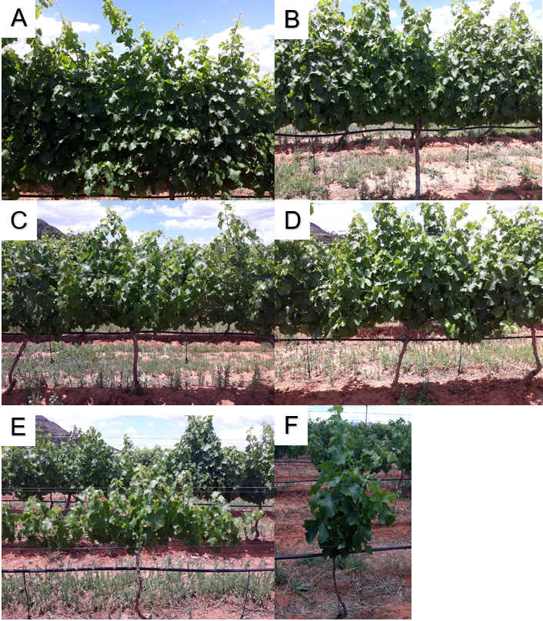
Fig. 1 Visual differences of Sauvignon blanc vines grafted onto different rootstocks and subjected to four irrigation treatments* to demonstrate the visual differences between some of the rootstocks within irrigation treatments. A: Control Irrigation. B: (⅔C) irrigation. C: (⅓C) irrigation D: No irrigation, Ramsey as rootstock. E: No irrigation, Richter 99 as rootstock. F: No irrigation, 101-14 Mgt as rootstock. *Irrigation: a) Full surface irrigation was applied according to ET₀-values from the weather station on the research farm (Control); b) Full surface irrigation of 33% less than the volume for the control (⅔ of Control); c) Full surface irrigation of 66% less than the volume for the control (⅓ of Control); d) No irrigation during the entire growth season.

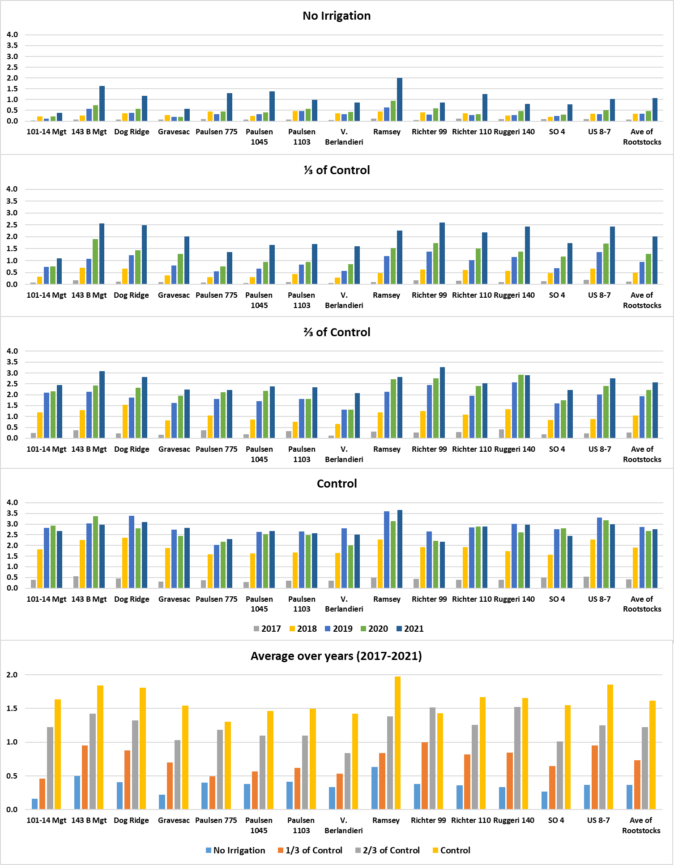
Fig. 2. Cane mass (t/ha) of Sauvignon blanc vines grafted onto different rootstocks and subjected to four irrigation treatments*, as measured during pruning from 2017 to 2021. *Irrigation: a) Full surface irrigation was applied according to ET₀-values from the weather station on the research farm (Control); b) Full surface irrigation of 33% less than the volume for the control (⅔ of Control); c) Full surface irrigation of 66% less than the volume for the control (⅓ of Control); d) No irrigation during the entire growth season.
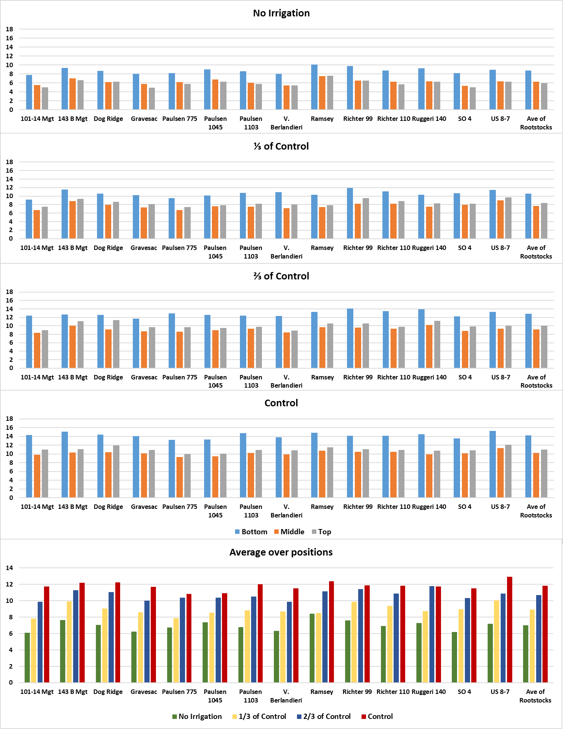
Fig. 3. Average trunk circumference (cm) of Sauvignon blanc vines grafted onto different rootstocks and subjected to four irrigation treatments*, as measured prior to pruning for 2018 to 2021. *Irrigation: a) Full surface irrigation was applied according to ET₀-values from the weather station on the research farm (Control); b) Full surface irrigation of 33% less than the volume for the control (⅔ of Control); c) Full surface irrigation of 66% less than the volume for the control (⅓ of Control); d) No irrigation during the entire growth season.
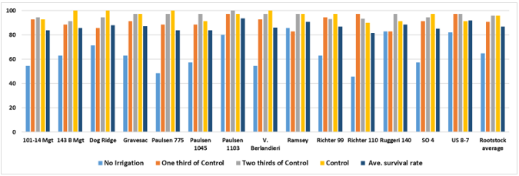
Fig. 4. Survival rate (%) of Sauvignon blanc vines grafted onto different rootstocks and subjected to four irrigation treatments*, since the establishment of the vineyard as measured in August 2021. *Irrigation: a) Full surface irrigation was applied according to ET₀-values from the weather station on the research farm (Control); b) Full surface irrigation of 33% less than the volume for the control (⅔ of Control); c) Full surface irrigation of 66% less than the volume for the control (⅓ of Control); d) No irrigation during the entire growth season.

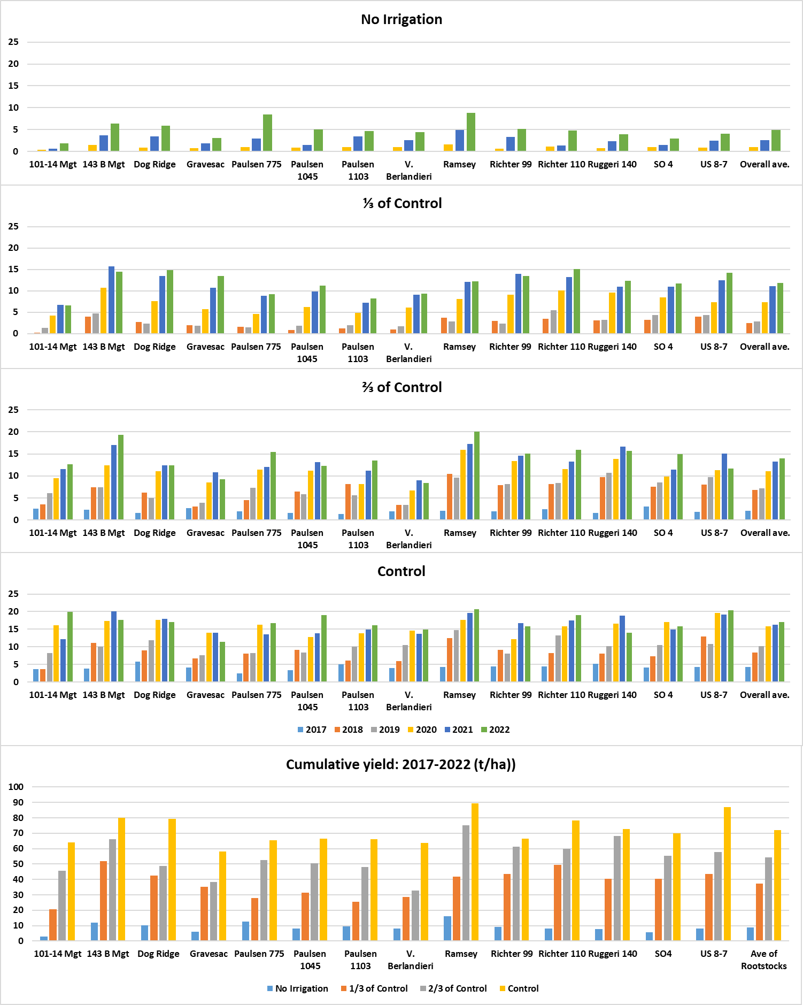
Fig. 5. Yield (t/ha) of Sauvignon blanc vines grafted onto different rootstocks and subjected to four irrigation treatments*, from the 2016/17 to the 2021/22 growth season. *Irrigation: a) Full surface irrigation was applied according to ET₀-values from the weather station on the research farm (Control); b) Full surface irrigation of 33% less than the volume for the control (⅔ of Control); c) Full surface irrigation of 66% less than the volume for the control (⅓ of Control); d) No irrigation during the entire growth season.
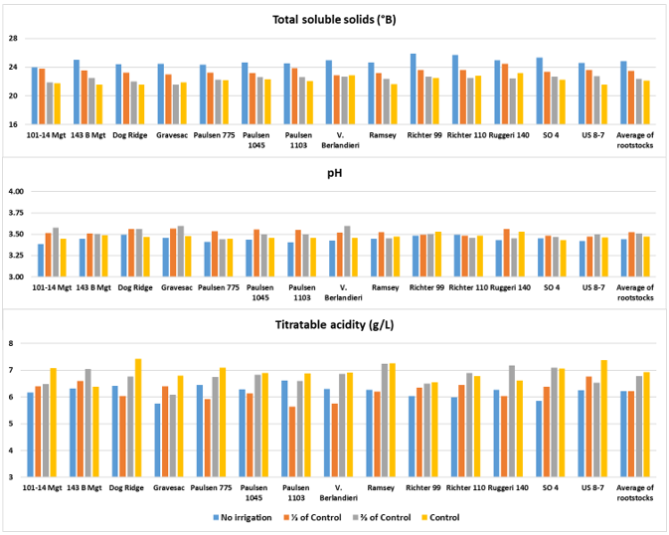
Fig. 6. Average grape composition of Sauvignon blanc grapes grafted onto different rootstocks and subjected to four irrigation treatments*, from the 2018/19 to the 2021/22 seasons. *Irrigation: a) Full surface irrigation was applied according to ET₀-values from the weather station on the research farm (Control); b) Full surface irrigation of 33% less than the volume for the control (⅔ of Control); c) Full surface irrigation of 66% less than the volume for the control (⅓ of Control); d) No irrigation during the entire growth season.

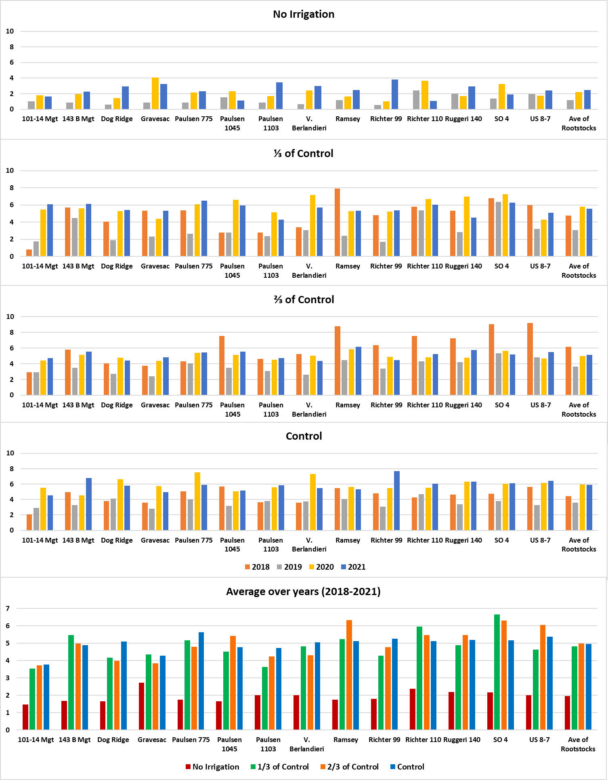
Fig. 7. Ravaz Index (Yield to cane mass ratio) of Sauvignon blanc vines grafted onto different rootstocks and subjected to four irrigation treatments*, from 2017/18 to 2020/21 growth seasons. *Irrigation: a) Full surface irrigation was applied according to ET₀-values from the weather station on the research farm (Control); b) Full surface irrigation of 33% less than the volume for the control (⅔ of Control); c) Full surface irrigation of 66% less than the volume for the control (⅓ of Control); d) No irrigation during the entire growth season.

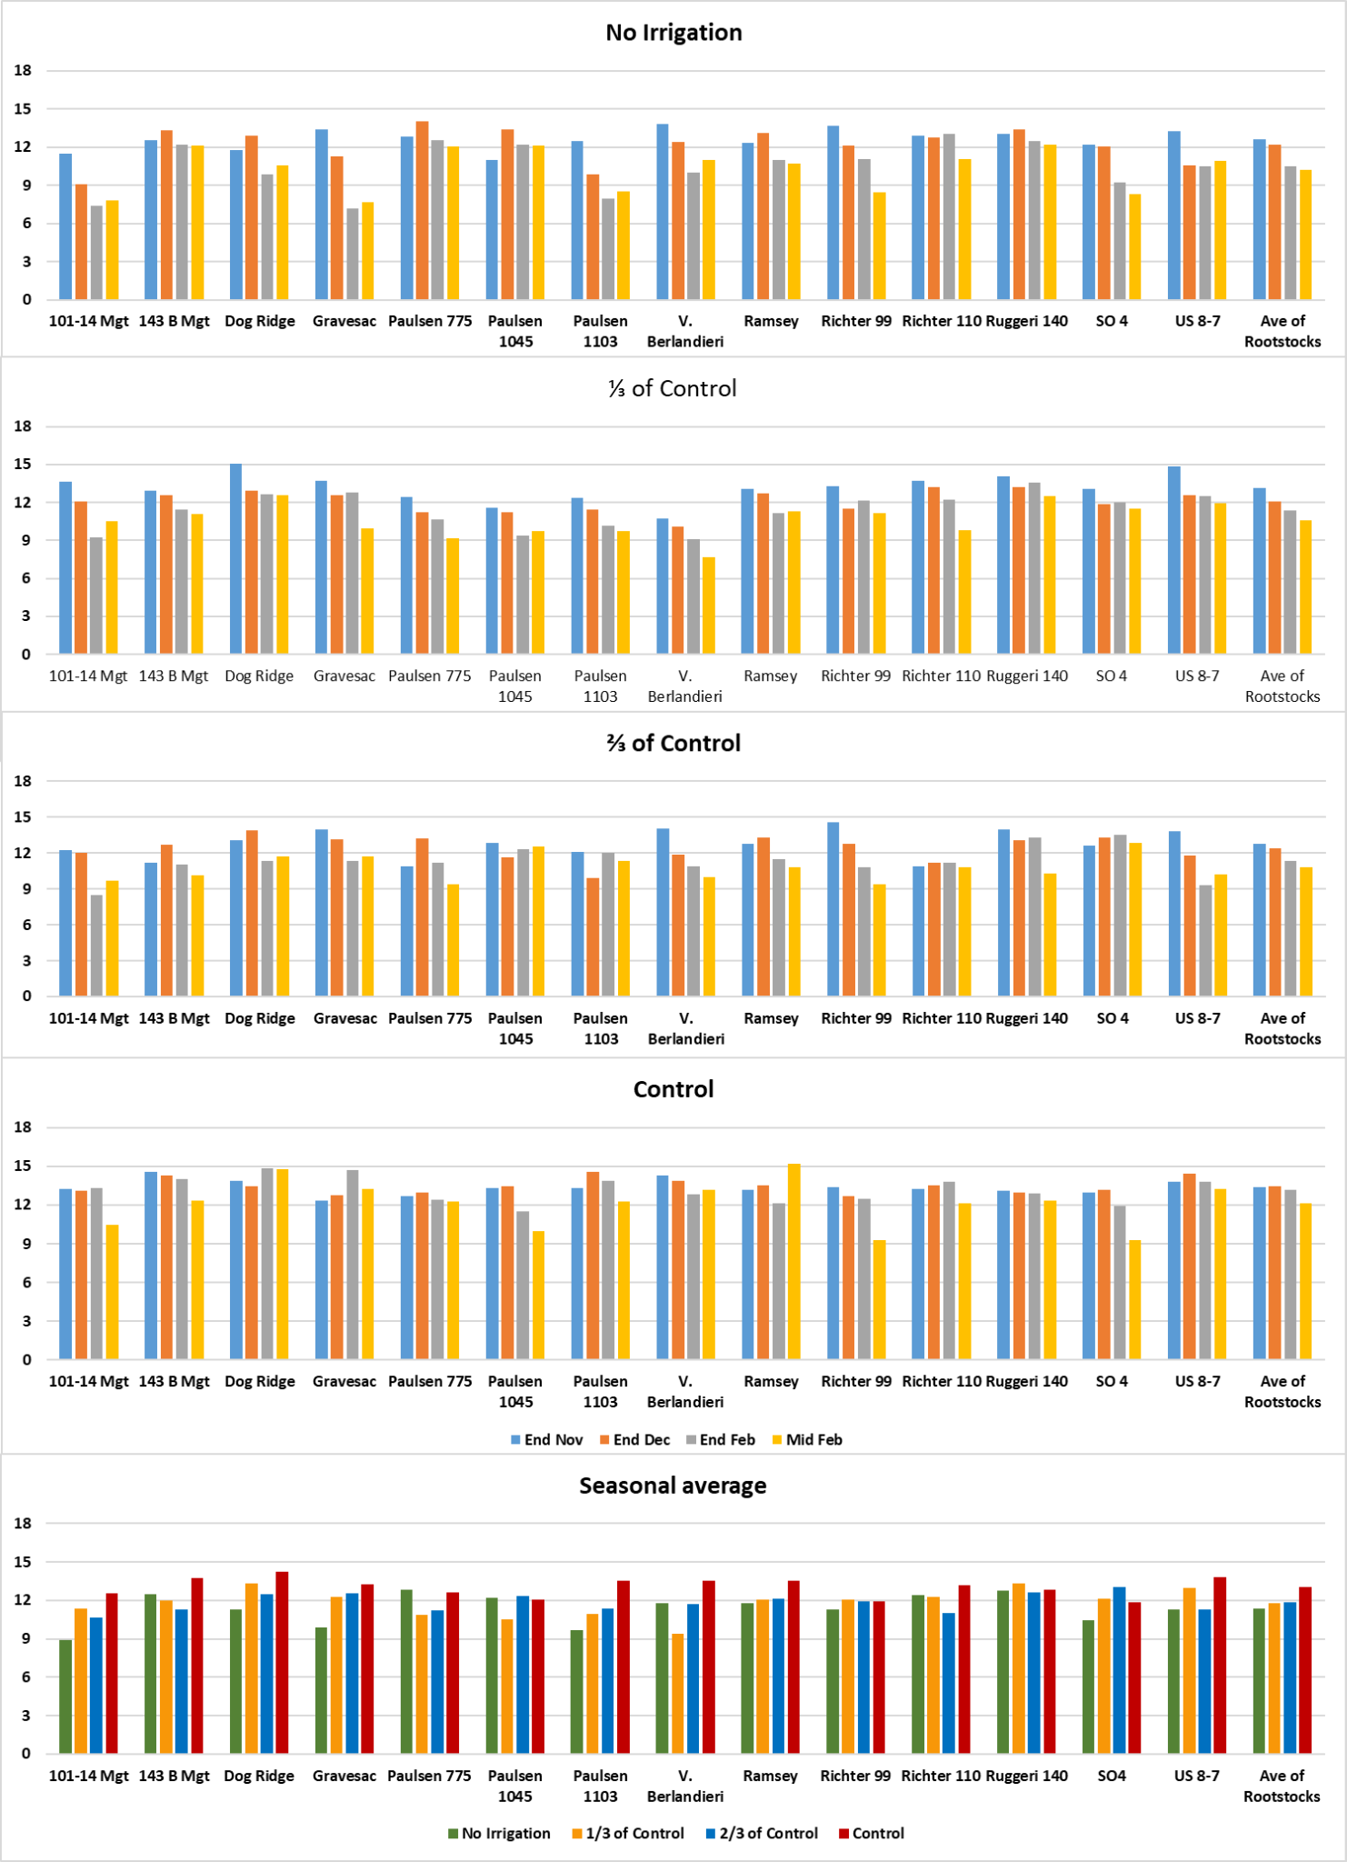
Fig. 8. Net photosynthesis (µmol CO₂.m⁻².s⁻¹) of Sauvignon blanc vine leaves grafted onto different rootstocks and subjected to four irrigation treatments, from the 2017/18 to the 2021/22 growth seasons.

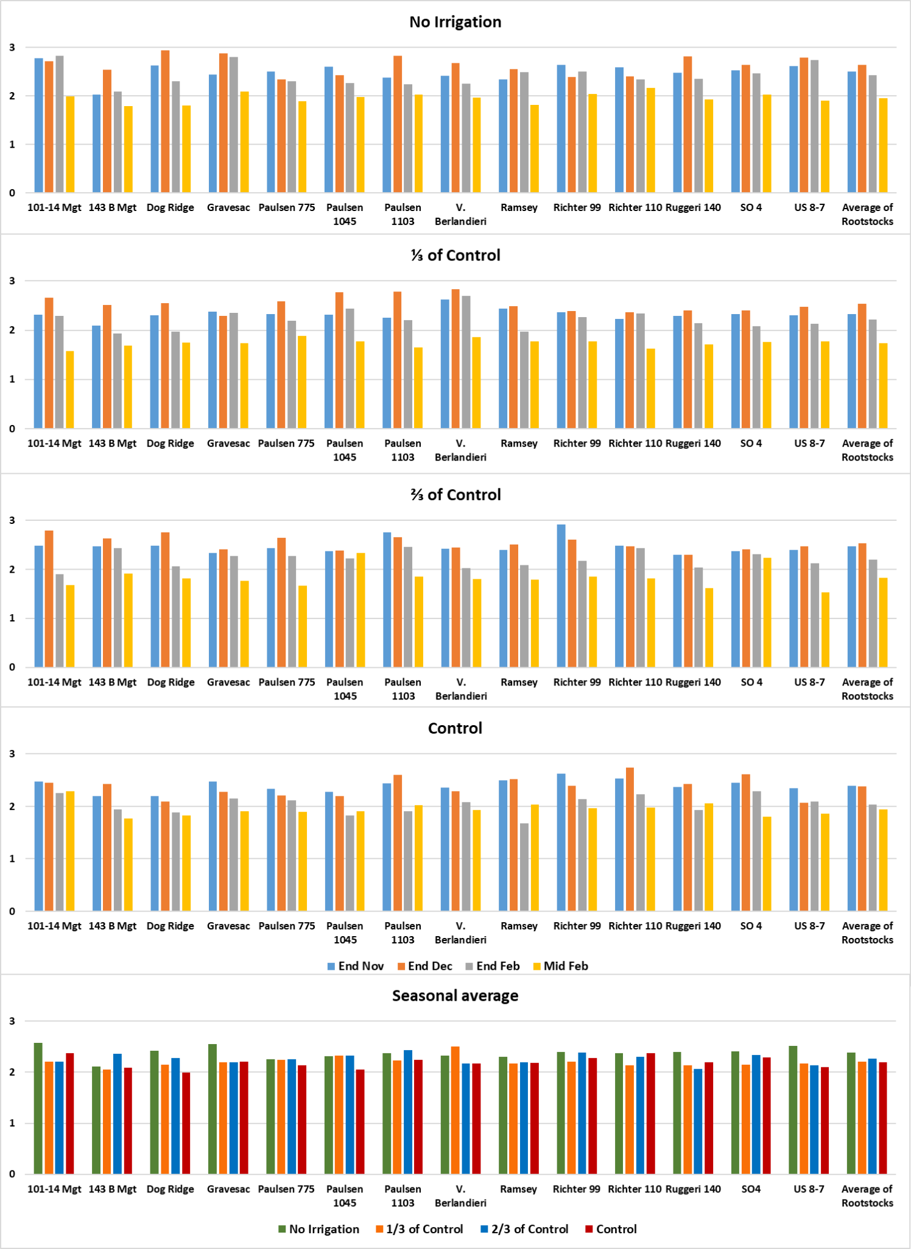
Fig. 9. Average WUE of Sauvignon blanc vine leaves grafted onto different rootstocks and subjected to four irrigation treatments, as measured from the 2017/18 to 2021/22 growth seasons. 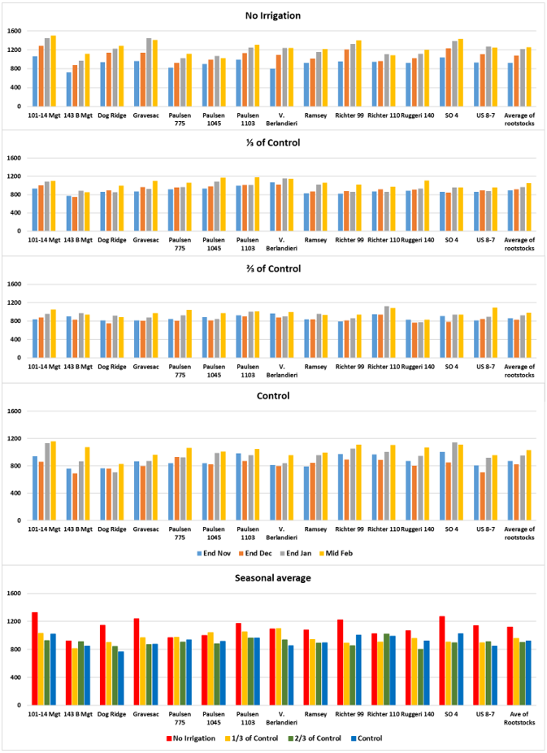
Fig. 10. Average stem water potential (-kPa) of Sauvignon blanc vine leaves grafted onto different rootstocks and subjected to four irrigation treatments* from the 2017/18 to the 2021/22 growth seasons.

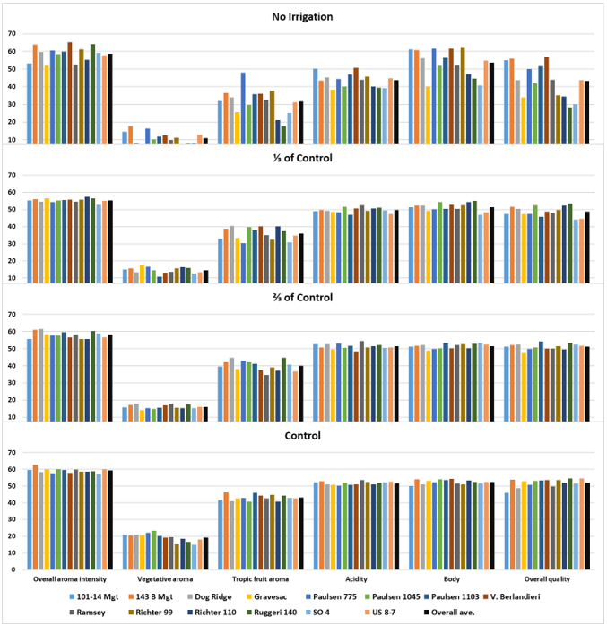
Fig. 11. Characteristics (%) of Sauvignon blanc wines made of grapes from vines grafted onto different rootstocks and subjected to three irrigation treatments of the 2018/19 to the 2020/21 seasons. *Irrigation: a) Full surface irrigation was applied according to ET₀-values from the weather station on the research farm (Control); b) Full surface irrigation of 33% less than the volume for the control (⅔ of Control); c) Full surface irrigation of 66% less than the volume for the control (⅓ of Control); d) No irrigation during the entire growth season.
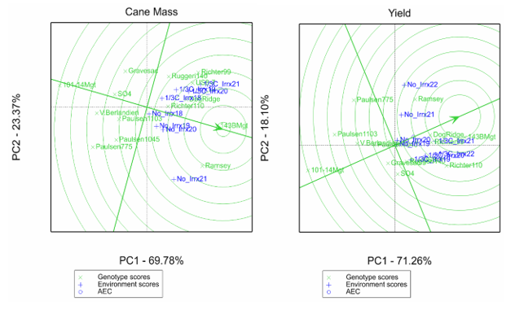
Fig. 12. Genotype plus Genotype by Environment (GGE) comparison biplots to show the effect of irrigation by year treatment combinations on the rootstocks of cane mass and yield.

8. CONCLUSIONS AND RECOMMENDATIONS

An average survival rate of more than 60% for non-irrigated S. blanc vines grafted onto the 14 different rootstocks was recorded after the establishment of the research vineyard on a clay/loam soil on the ARC-Robertson research farm. This was probably the result of high and well-distributed rainfall of 285 mm that occurred during the 2013/14 growth season after establishment. Exceptionally high survival rates of more than 80% were found for vines grafted onto Ramsey, Ruggeri 140, US 8-7 and Paulsen 1103. An average survival rate of 91% was recorded for the (⅓C) irrigated, compared to 94% and 95% for the (⅔C) and the control irrigated vines, respectively. The combination of irrigation and rainfall was necessary for a good survival rate and young vine development at the beginning of this investigation.

Even though only 80 mm of rain fell during the 2021/22 growth season, of which most occurred before the ripening period, stress symptoms at harvest of vines subjected to the non- and low irrigation treatments were less pronounced than in previous years and at the beginning of the investigation. It seems that some vines adapted better to these severe drought conditions induced by the non and (⅓C) irrigation treatments, especially the S. blanc vines grafted onto Ramsey, 143 B Mgt, and Paulsen 775. No clear rootstock-related patterns were found for physiological measurements. However, average stem water potential and photosynthetic activity decreased with the progression of the season for all irrigation treatments, but increased with an increase in the volume of irrigation water applied.

As expected, cane mass increased with an increase in the volume of irrigation water applied during the preceding growth season, but the non- and deficit irrigated vines showed an increase in cane mass for the past four years, despite continued vine development. This was not the case for the control irrigated vines, as cane mass was relatively constant. This indicates that the non- and deficit irrigated vines have not settled yet during the period of the investigation and are still continuing to develop in structure and root system. Non-irrigated vines grafted onto Ramsey, and 143 B Mgt showed high survival rates as well as growth during the preceding three seasons. During the last season, high growth was also found for Paulsen 775, Paulsen 1045 and Richter 110. Furthermore, decent growth was found for vines grafted onto 143 B Mgt, Richter 99 and US 8-7 of the (⅓C) irrigation treatment during this period.

As for the 2020 and 2021 harvests, the average production of non-irrigated S. blanc vines grafted onto the different rootstocks more than doubled during 2022, especially for vines grafted onto Ramsey, Paulsen 775, Richter 110 and 143 B Mgt. Although not the highest every year, production of vines grafted onto 143 B Mgt was very good compared to the average for rootstocks during the past five years and resulted in the highest cumulative yield for the (⅓C) irrigation treatment. Good comparable cumulative yields were found for vines grafted onto Richter 110 and Ramsey for this irrigation treatment under these cultivation conditions.

It is quite clear that vine performance was reduced and delayed by extreme deficit irrigation strategies like the non- and (⅓C) irrigation treatments, and that growth of vines was also more diverse under these conditions than under luxurious irrigation. It was therefore important to apply different pruning strategies to maintain balanced growth under extreme conditions. These pruning strategies and the different rootstocks used in the vineyard resulted in a diverse appearance of vines in the experimental vineyard. However, it is unclear if the current performance of some rootstocks will continue and for how long and if other rootstocks will outperform them at a later stage. The premature termination of the project effectively nullifies the outcomes, value and cost-effectiveness of the project.

9. PLANNED OUTPUTS
a) TECHNOLOGY DEVELOPMENT, PRODUCTS AND PATENTS
None
b) SUGGESTIONS FOR TECHNOLOGY TRANSFER
Due to the premature termination of the project and the fact that the long-term performance of the rootstocks was not determined, the technology transfer is very risky.
c) HUMAN RESOURCES DEVELOPMENT / TRAINING (STUDENTS)
{Honours}{Masters}{PhD}{Postdocs}
Student Name and Surname | Student Nationality | Degree (e.g., Hons, MSc) | Level of studies in the final year of the project | Total Bursary Cost for Industry for the entire project
Honours
Masters
PhD
Postdocs

d) LIKELY PUBLICATIONS (POPULAR, PRESS RELEASES, SCIENTIFIC)
None

e) PRESENTATIONS/PAPERS THAT COULD BE DELIVERED
Volschenk CG, Hunter JJ. (2013) Evaluation of existing wine grape rootstocks for their ability to withstand the environmental challenges. Presentation at SASEV/Winetech Congress at Somerset West, South Africa, 13 - 15 November 2013
10. PROJECT OUTCOME AND IMPACT

New Knowledge | Benefits Supply Chain | Direct Grower Application | Direct Packhouse/Winery/ Cellar Application | Other
 |  | X

The other is:
The Value of the project to the industry

South Africa is a water-scarce country. Climate change and socio-economic challenges will make the management of water resources more difficult. The project could have provided answers regarding the most suitable rootstocks to obtain sustainable yields for different terroirs. The premature termination of the project, unfortunately, seriously impacts the value of the outcomes.
11. PERSONS PARTICIPATING IN THE PROJECT:
INITIALS AND SURNAME | HIGHEST QUALIFICATION | RACE (M, W) | GENDER (M, F) | INSTITUTE DEPARTMENT | POSITION | TOTAL COST TO PROJECT
RESEARCH PERSONNEL |  |  |  |  |  | R 0
JJ Hunter | PhD | W | M | ARC | Co | R 0
CG Volschenk | MSc | W | M | ARC | PL | R 0
SUPPORT PERSONNEL |  |  |  |  |  | R 0
LF Adams | Grade 12 | B | M | ARC | TA | R 0
AJ Marais | Grade 10 | W | F | ARC | RA | R 0

POSITION: Co = Co-worker (other researcher at your institution)
Coll = Collaborator (participating researcher that does not receive funding for this project from industry)
PF = Post-doctoral fellow
PL = Project leader
RA = Research assistant
TA = Technical assistant/ technician

12. TOTAL COST OF PROJECT
TOTAL ANNUAL COSTS (ALL YEARS) | CFPA | RAISIN SA | HORTGRO | SATI | WINETECH | ARC | OTHER | TOTAL
2017 | R 0 | R 0 | R 0 | R 0 | R 534314 | R 556123 | R 0 | R 1090437
2018 | R 0 | R 0 | R 0 | R 0 | R 577059 | R 600613 | R 0 | R 1177672
2019 | R 0 | R 0 | R 0 | R 0 | R 607990 | R 632809 | R 0 | R 1240799
2020 | R 0 | R 0 | R 0 | R 0 | R 412823 | R 640296 | R 0 | R 1053119
2021 | R 0 | R 0 | R 0 | R 0 | R 431510 | R 652902 | R 0 | R 1084412
2022 | R 0 | R 0 | R 0 | R 0 | R 0 | R 481599 | R 0 | R 481599
TOTAL | R 0 | R 0 | R 0 | R 0 | R 2563696 | R 3564342 | R 0 | R 6128038

